**ANL 488 FINAL REPORT**

**RENEWABLE ENERGY GENERATION AND DEPENDENCY IN SINGAPORE**



**Submitted by**

**LOW PEI XUAN**

**SCHOOL OF BUSINESS Singapore University of Social Sciences**

**Presented to Singapore University of Social Sciences in partial fulfillment of the requirements for the  
Degree of Bachelor of Science**

**2023**

# **ABSTRACT**

This study involves forecasting the three main aspects of renewable energy dependency in Singapore. These three factors include electricity consumption level, renewable electricity generation level and total population in Singapore. The electricity consumption dataset and renewable electricity generated dataset were sourced from Energy Market Authority Singapore (EMA) and obtained from Singstat online. The Total Population dataset was sourced from International Energy Agency (IEA Statistics) and obtained through the world bank. This study proposes the usage of the mentioned two time series analysis techniques namely the ARIMA model and Holt’s method to predict the next two decades of forecasted values of the three main aspects of renewable energy dependency mentioned above. Both modelling techniques were successful in forecasting future values for all three datasets. The Holt’s method is the winner model for both the electricity consumption and total population dataset where the Holt’s method predicted an increase in electricity consumption levels up till 2043 but predicted a decrease in total population in the future. The ARIMA model was chosen as the winner model for the renewable electricity generated dataset where it is predicted to increase in the future. While although both the electricity consumption level and renewable electricity generated is stipulated to increase in the future, Singapore is still unable to full depend on renewable energy in the coming future as renewable electricity generation level will never be able to generate at least 60% of the nation’s electricity consumption level as at year 2043.

Table of Contents

ABSTRACT ii

Introduction 1

***Business Problem*** 1

***Business Analytics Problem*** 2

Literature Review 2

*Regression models* 3

*Artificial Neural Network (ANN)* 3

*Time Series Analysis* 4

Data Understanding and Preparation 6

***Data Understanding*** 6

Table 1: Data Dictionary for Structured Data 7

***Data Preparation*** 7

**Singapore’s Electricity Consumption Dataset** 8

**Singapore’s Renewable Electricity Generated Dataset** 14

**Singapore’s Total Population Dataset** 17

Modelling and Evaluation 20

*ARIMA MODEL* 21

*DOUBLE EXPONENTIAL SMOOTHING (HOLT’S) METHOD* 22

***Model Comparison Table*** 27

**Singapore’s Renewable Electricity Generated Dataset** 28

***Model Comparison Table*** 30

**Singapore’s Total Population Dataset** 31

***Model Comparison Table*** 34

**Winner Models** 35

Model Results / Discussion 35

Recommendations / Conclusion 37

Project Limitations 40

References 41

Appendix 49

**Project Title: Renewable energy generation and dependency in Singapore**

# **Introduction**

Global warming and climate change has been a persistent dire matter for decades now, and with technology taking the world over, the situation will only worsen as electricity consumption continues to rise with the use of technology in our daily lives. There is no doubt that electricity plays an important role in a nation’s economic productivity and with the increase in electricity demand worldwide, the primary resources used to generate electricity is depleting at an alarming rate that give rise to both economic and environmental concerns. (Yoo, S.-H. ,2006 ; Kuo, 2019)

Now then, how can we continue to consume high volumes of electricity while limiting the impacts it will have on the environment? The answer is the adoption of renewable electricity (RE). Renewable electricity as its name suggests refers to electricity produced from renewable sources that are easily reproducible in short periods of time, for example electricity generated from indefinite solar power. (Shinn, 2022) As the generation of electricity from renewable sources produces less harmful emissions like Carbon Dioxide (CO2) and Sulfur dioxide (SO2) etc, it is considerably more environmentally friendly. However, Singapore’s main electricity source today still comes from non-renewable sources such as natural gas. (Powering Lives, 2023)

## ***Business Problem***

As resources are depleting and electricity security is threatened, the objective of this study is to find out if Singapore is able to depend on renewable electricity in the future.

To deduce this, our study aims to predict Singapore’s renewable electricity generation level, electricity consumption level and total population. These are the three important aspect needed to analyse and deduce if Singapore’s current level of electricity generated through renewable sources will increase in the future to supplement at least 60% of the nation’s electricity consumption level. This will shine light on whether Singapore’s renewable electricity supply is able to sustain the nation’s electricity consumption levels for the next two decades to come.

## ***Business Analytics Problem***

The business analytics problem is to evaluate suitable modelling techniques that will help our study deduce Singapore’s dependency on renewable electricity through forecasting techniques applicable to predict Singapore’s electricity consumption, renewable electricity generated and population. The most ideal modelling technique for our datasets will then be further analysed and discussed.

# **Literature Review**

Being the most used energy source in the world, the consumption of electricity becomes a mixed blessing as it helps with a nation’s economy but possibly harms the environment if not used and produced sustainably. (IEA, 2023, *Electricity - Energy System*) Hence, measures to ensure more usage of renewable electricity should be put in place to reduce the harm electricity consumption can have on the environment. Ever since the pandemic, there was an increase in the overall electricity consumption level in Singapore which leads to the pressing question: “Is the current renewable electricity supply rate in Singapore sufficient to feed the nation’s electricity consumption rate in the long run?”. (Goh, 2020) To answer this question, predictive analysis needs to be conducted to predict the nation’s population, level of electricity consumption and renewable electricity generation till 2030.

After reviewing literatures related to electricity consumption and energy dependency topics, most studies used predictive and time series models such as Regression, Artificial Neural Network (ANN), ARIMA and Holt’s Winter test on time series datasets. Hence, we will be reviewing each of these models and their respective literatures to identify the models used, their findings as well as potential loopholes not addressed by the literature reviews.

## *Regression models*

Rekhade, R., & Sakhare, D. K. (2021) conducted a research on sector-wide electricity consumption in India using 4 regression models namely, linear, logarithmic, power and exponential regression models. They collected and studied yearly data from 1970 to 2018 from sectors such as industry, domestic, agriculture, commercial, traction and railways. Among the 4 regression approaches which all proves to be accurate, exponential regression model performed the best with the lowest MAPE value. However, as this study solely focused on regression models, the study pointed out that future studies should include a variety of forecasting techniques such as ANN and time series models as well as other important factors affecting electricity consumption such as GDP and population.

## *Artificial Neural Network (ANN)*

In terms of variation, Pannakkong, W., Harncharnchai, T., & Buddhakulsomsiri, J. (2022) forecasted daily electricity consumption level in Thailand using a variety of forecasting methods such as Regression, Artificial Neural Network (ANN), Support Vector Machine, and Hybrid Models. Interestingly, it was concluded that the Hybrid Models comprising of 3 features, namely a hybrid Multiple Linear Regression (MLR), five ANN models tuned by sequential grid search, and national holiday indicator variables provided the best overall performance with the smallest MAPE value when compared to other traditional models alone. The variety of models explored in this study gave a good comparison between the accuracy of regression and ANN models. However, time series models was not discussed in this study to give a higher level of comparison between predictive models and time series analysis models.

Other than electricity consumption, another study adopted ANN to predict energy dependency based on sector-wide energy consumption. Sozen, A. (2009) predicted energy dependency in Turkey using numerical equations based on sectoral energy consumption and basic energy indicators. This study used 2 models containing main energy indicators and sectoral energy consumption to train the neural network. ANN was concluded to show high accuracy, making it possible to predict energy dependency from sectoral energy consumption.

Although ANN seem like a viable model to predict future energy consumption and dependency, our study would like to adopt a more interpretable model as performing analysis on the predicted data is important in this study.

## *Time Series Analysis*

As time series data are used in studies related to electricity consumption and energy dependencies, there is no doubt that time series models should be considered when predicting future electricity consumption, renewable energy generation and population.

In a study conducted by Manni, U. H., & Datuk. Dr. Kasim Hj. Md. Mansur. (2022), Holt-winters’ test is adopted to predict the renewable power capacity and generation in Indonesia to estimate if the nation is able to reach its SDG7 goal by 2030. Both the additive and Multiplicative method were conducted where the additive method proves to work better with the given dataset. It was concluded that Indonesia’s existing renewable power capacity and generation rate is unable to reach the nation’s SDG7 objective by 2030 although an increase in the power capacity and generation level was predicted. The Holt-winters’ time series model is concluded as a highly effective predictive tool in this study where a decision tree regression model is used to further improve the model’s accuracy that is validated using the ACF and Ljung-box tests. As this study also only focuses on one time series model, it lacks comparability between different time series models.

Asadi, M., Larki, I., Mohammad, M. F., Ahmadi, R., & Farajollahi, M. (2023) used time series algorithms of ARIMA, single exponential smoothing and Holt to predict electricity consumption, population and CO2 emissions from power plants in Iran. Among the 3 algorithms used, the Holt method returns the lowest MAPE % when predicting on electricity consumption. The ARIMA model is deemed as the best performing model when predicting both the population and CO2 emission. As this study is the only study closely related to our study in terms of variables to be predicted, results and result interpretation, our study will be taking this study into account and implementing similar models into Singapore’s context to achieve the goal of our study.

Although the above-mentioned studies were able to successfully predict energy consumption using the various models, little to no literature we have come across, conducted studies on renewable energy dependency on a highly-developed country like Singapore who faces many challenges in renewable energy generation options. As our study aims to see if Singapore’s current efforts in generating renewable electricity is able to produce enough electricity in the future for future consumption, it is a question about time. Hence, time series modelling is picked to be the models used in this study.

Hence, our study serves to determine which time series model will be the best suited model in predicting 3 datasets namely, Singapore’s electricity consumption, Singapore’s renewable energy generation and total population. The results derived from this study will value-add this highly buzzed about but rarely explored sector (Renewable energy) in Singapore which is crucial in helping Singapore anticipate the sustainability of renewable electricity and realise actionable steps to safeguard electricity security for future generations. By identifying the various research gaps in above-mentioned studies, we are able to realise suitable models required and compare them to gain insights on Singapore’s electricity consumption and renewable electricity generation capacity to determine the nation’s dependency on renewable energy.

# **Data Understanding and Preparation**

## ***Data Understanding***

In this study, 3 datasets consisting of data related to Singapore’s electricity consumption, renewable electricity generated and total population will be examined.

These datasets were retrieved namely from Singstat, sourced from Energy Market Authority Singapore (EMA) and the World Bank, sourced from International Energy Agency (IEA Statistics). Singstat is the nation’s statistical office where official statistics are being collected and compiled. (Department Of Statistics Singapore, 2023) The source of the data from singstat is provided by EMA which is the nation’s power system operator, energy industry developer and Singapore’s energy industry regulator. (Energy Market Authority, 2023, *Industry Liscence*) The World Bank works in major area of developments around the world, they compile officially-recognised international sources. (The World Bank, 2023) The particular source of data we are using in our study comes from the IEA statistics, which is an organisation that works with governments and industries on sustainable energy projects. (IEA, 2023, *International Energy Agency - About*)

The 3 datasets consists of the following properties:

|  |  |  |  |  |
| --- | --- | --- | --- | --- |
| Dataset | Variable | Definition | Value | Time Period in Dataset |
| Electricity_Consumption  _1971_2014.csv | Electricity Consumption | Amount of electricity consumed measured in Kilowatt-Hour (kWh) | 1154.81 to  8844.69 kWh, NA | 1961 to 2022 |
| Electricity_From  _Renewables_new.csv | Renewable Electricity Generated | Electricity production from renewable sources in Kilowatt-hour (kWh) | 85000000.00 to  918000000.00 kWh, NA | 1960 to 2022 |
| Total_Population  _Column.csv | Singapore’s Population | The number of people residing in Singapore in plain number. | 1,022,100 to 5,637,022 | 1950 to 2022 |

### *Table 1: Data Dictionary for Structured Data*

## ***Data Preparation***

In order to prepare data for modelling, the above-mentioned datasets has to be cleaned for more accurate predictions. As these datasets came in an excel spreadsheet (.xlsx) together with other fields that are irrelevant to our current study, these variables are extracted from its raw excel spreadsheet into new CSV files that contains only the necessary variables respectively. These variables are also restructured from being in rows to now columns, making it readable in the python programme.

Hence, the study will be looking into these 3 excel spreadsheets, each containing 2 columns - Years and the respective variables (Electricity Consumption, Renewable Electricity Generated and Singapore’s population).

As we are dealing with time series data, the following are the steps needed to clean a time series data before modelling:

1) Handling missing or null values

2) Check for stationarity

3) Removing trend

4) Removing Seasonality

5) Ensure stationarity

Let us look at how each dataset was prepared for modelling.

### **Singapore’s Electricity Consumption Dataset**

#### 1) Handling Missing / Null Values

|  |  |  |
| --- | --- | --- |
|  | **Before** | **After** |
| **Missing Values** | 18 | 0 |
| **Range of data left** | 1961 to 2022 | 1971 to 2014 |
| **No. of rows left** | 61 | 43 |

*Table 2: Before and after handled missing values – Electricity consumption dataset*

As the electricity consumption dataset contains missing values, the 18 values spanning from 1961 to 1970 and 2015 to 2022 would be removed. It is important to replace or remove missing data as most machine learning algorithms cannot handle a dataset with missing values and it can cause deviation of results which is unfavourable for modelling and prediction. (Kumar, 2022) Here, null values are chosen to be discarded rather than replaced because these missing values are in consecutive periods spanning from 1961 to 1970 where measures to collect electricity consumption data might not have been put in place yet as Singapore was only founded in 1965. As this dataset was collected and consolidated in 2014, the missing values from 2015 to 2022 might suggests that they are data not yet collected by the source.

When missing values in this dataset was attempted to be replaced by mean, the dataset presented biasness and was not able to obtain stationarity. Hence, the missing values in this dataset is discarded for better prediction results. Refer to figure 1.2 and 1.3 in the appendix to view the removal of null values present in the electricity consumption csv file.

After removing the null values from the dataset, the original dataset with 2 columns and 62 rows is reduced to 2 columns and 44 rows of data. It consists of Kilowatts-hour (kWh) of electricity consumed in Singapore from years 1971 to 2014.

After dealing with missing values, we will do a simple check on the stationarity of the dataset to determine if the dataset is ready for modelling.

#### 2) Checking for Stationarity

Stationarity in a time series data would suggest that statistical properties are constant, and do not change over time. (G, 2023) Stationarity is crucial as most time series models rely on this aspect and assumes each time point is independent of one another with constant mean and variance over time. (Rasheed, 2020) Hence, it is important for a dataset to achieve stationarity before it can be used for modelling.

Here, we conduct a simple dickey fuller test to determine if the dataset is stationary.

*Checking Stationarity* ***before*** *differencing*

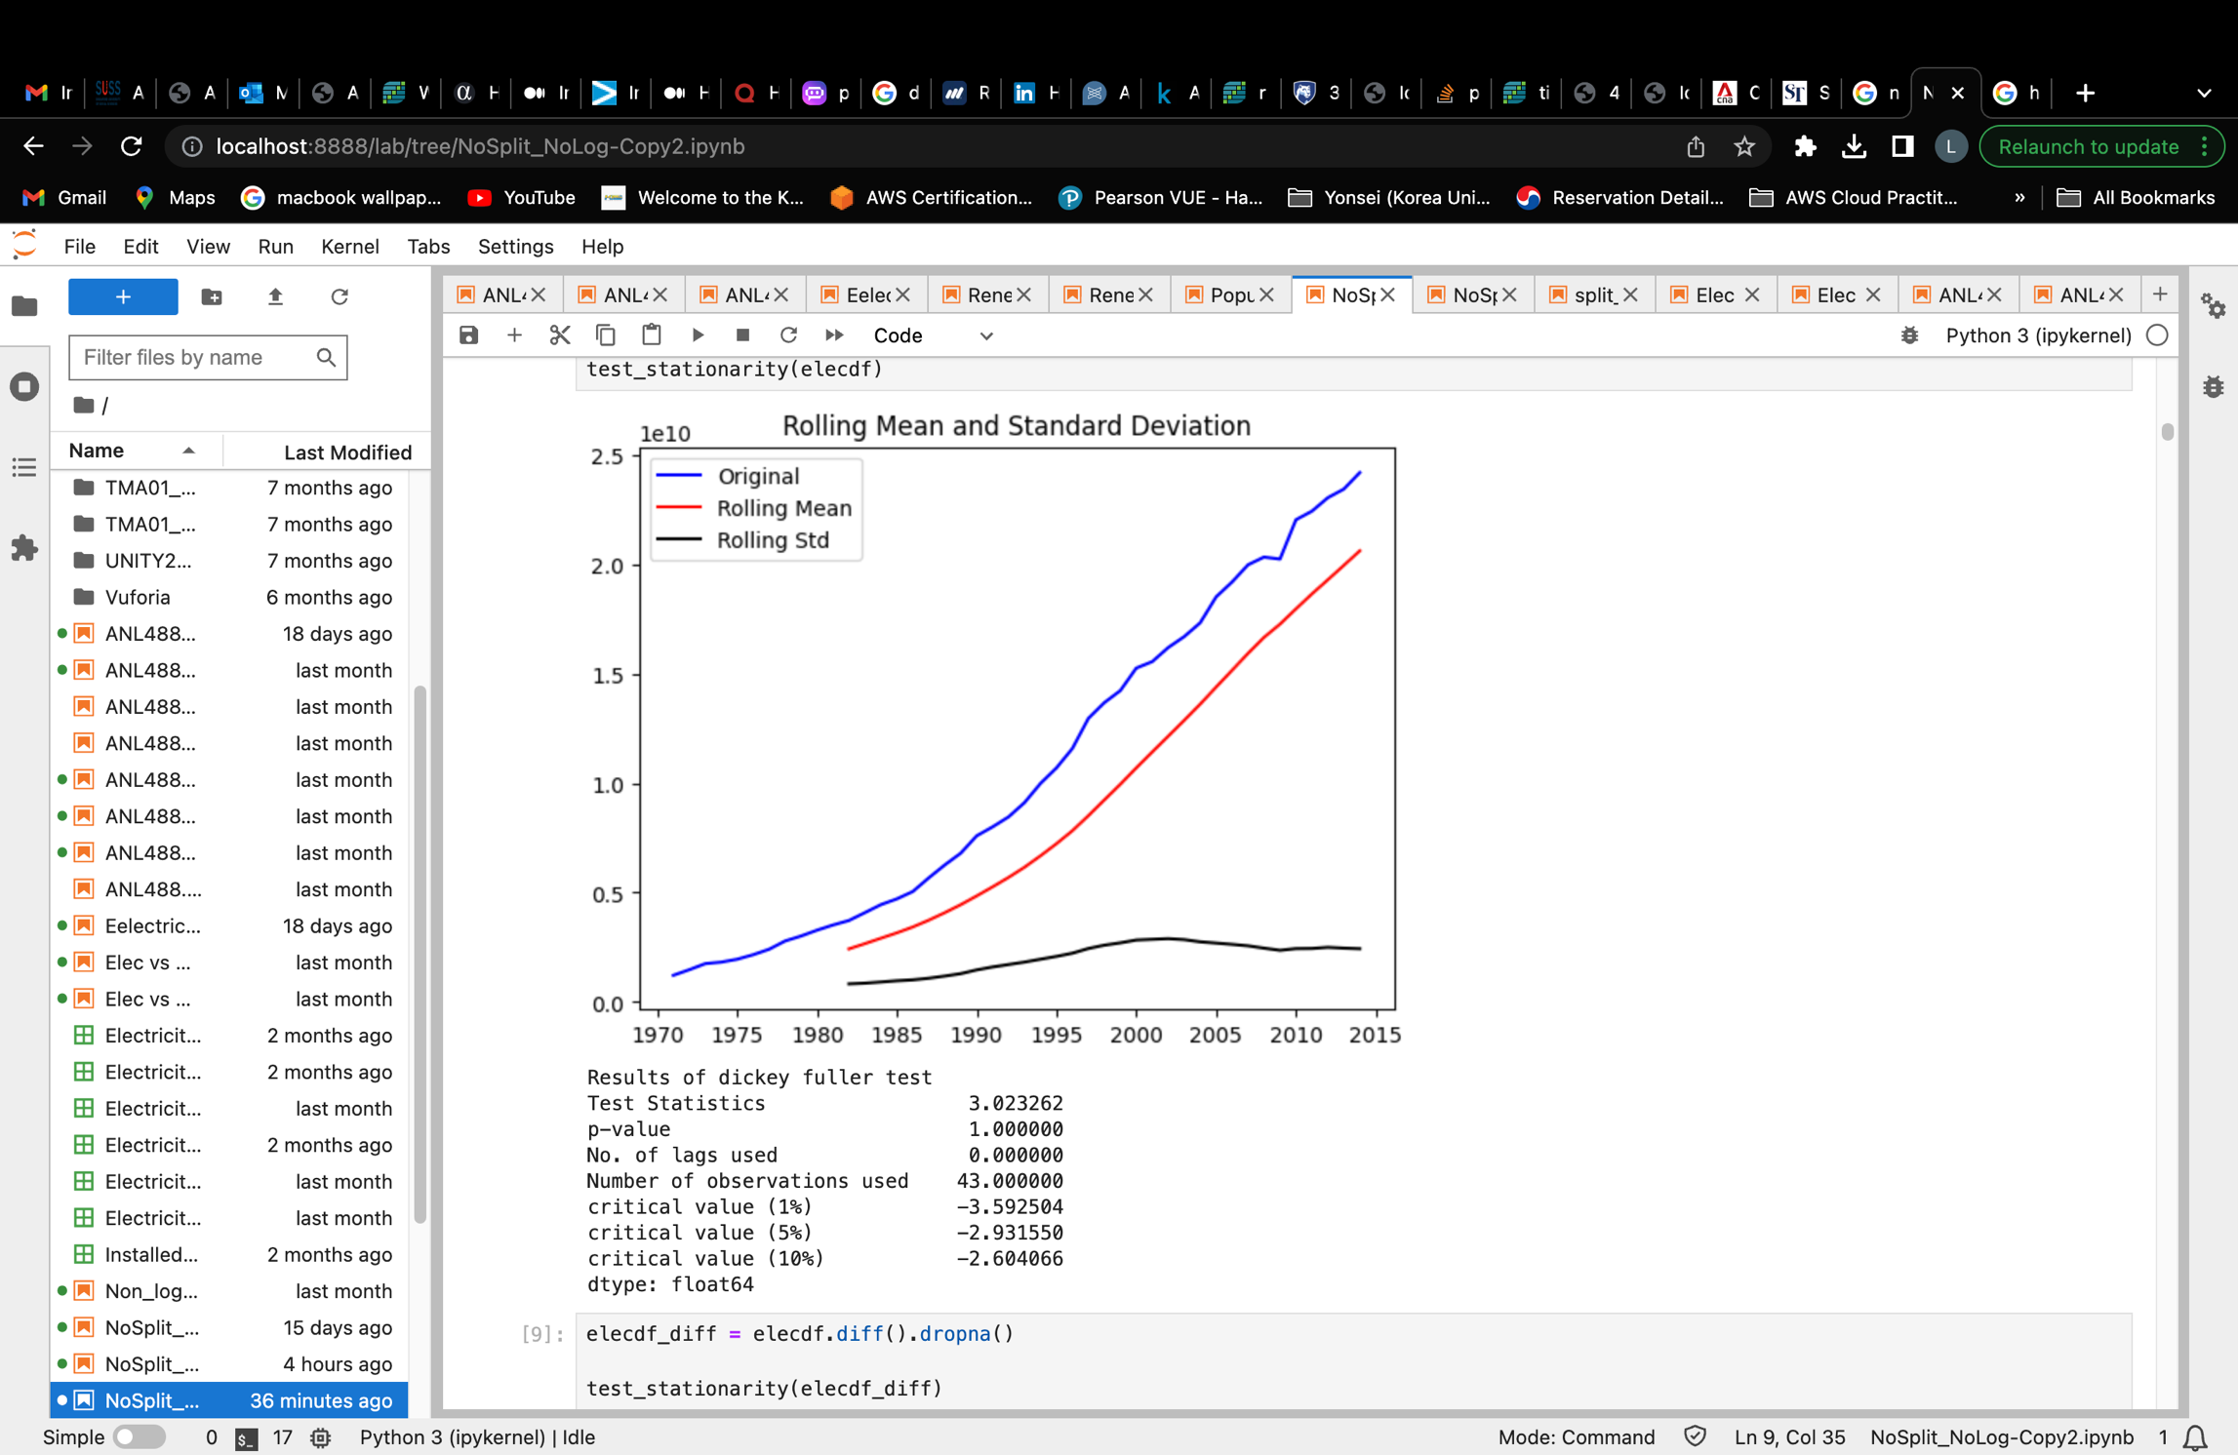

##### *Figure 1.4: Checking for stationarity in dataset before attempting to remove trend*

Figure 1.4 shows the results of the dickey fuller test conducted to investigate if the dataset is stationary before taking steps to ensure its stationarity. From the results, we can deduce that the dataset is not stationary.

This can be seen firstly, from the visual graph that this data has an upward trend.

Secondly, we can deduce stationarity from the p-value generated. This p-value determines if my null hypothesis of H0 = Data is not stationary is to be rejected or not. Rejecting the null hypothesis would mean that this data is stationary. To decide whether to reject the hypothesis, we will see if the p-value is <= 0.005. As 0.005 is our significance level, any p-value that is lesser than 0.005 would lead us to reject the hypothesis and deduce the data as stationary. However, since the p-value generated in figure 1.4 is greater than 0.005 at 0.67, we would not reject the hypothesis and this data is thus not stationary.

Lastly, we can also determine if the data is stationary by looking at whether the test statistics value is smaller than the critical values. If the test statistic value is smaller, it would mean that the data is stationary. However, in our case the test statistics is bigger than all 3 critical values, hence indicating that the data is not stationary.

After deducing that the data has a trend and is not stationary, we will be using differencing in an attempt to remove the trend present and achieve stationarity for this dataset.

#### 3) Removing trend

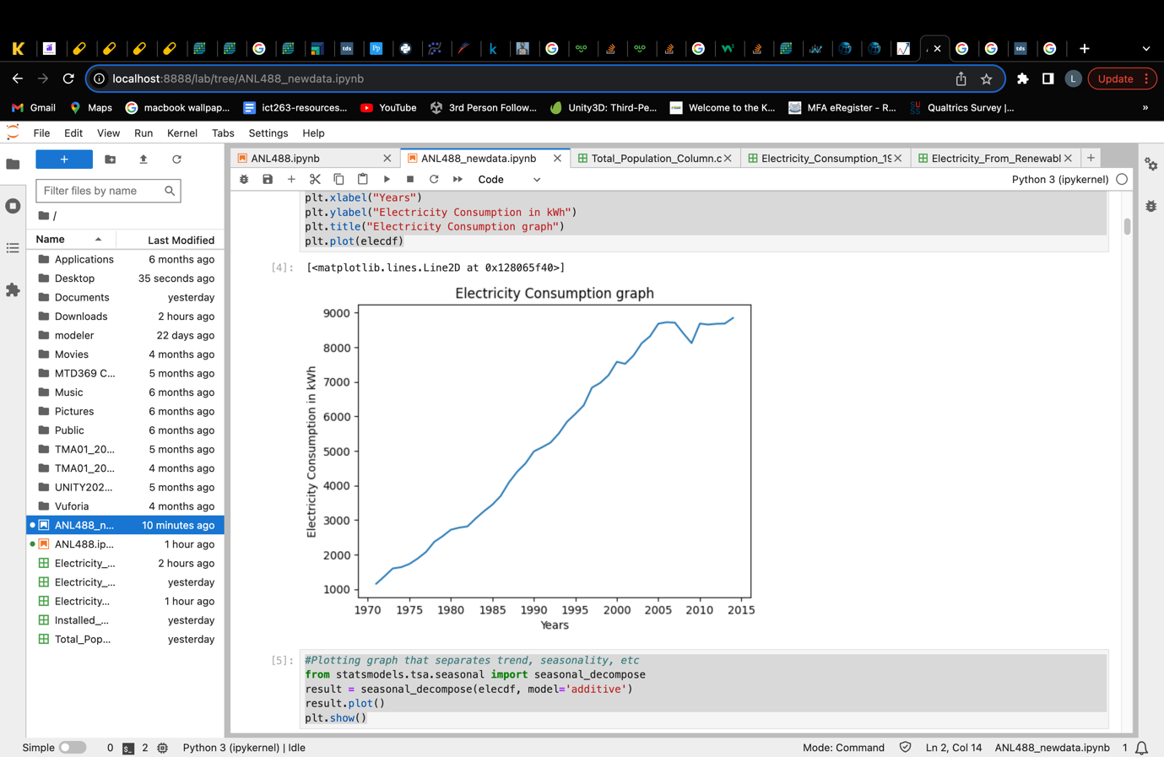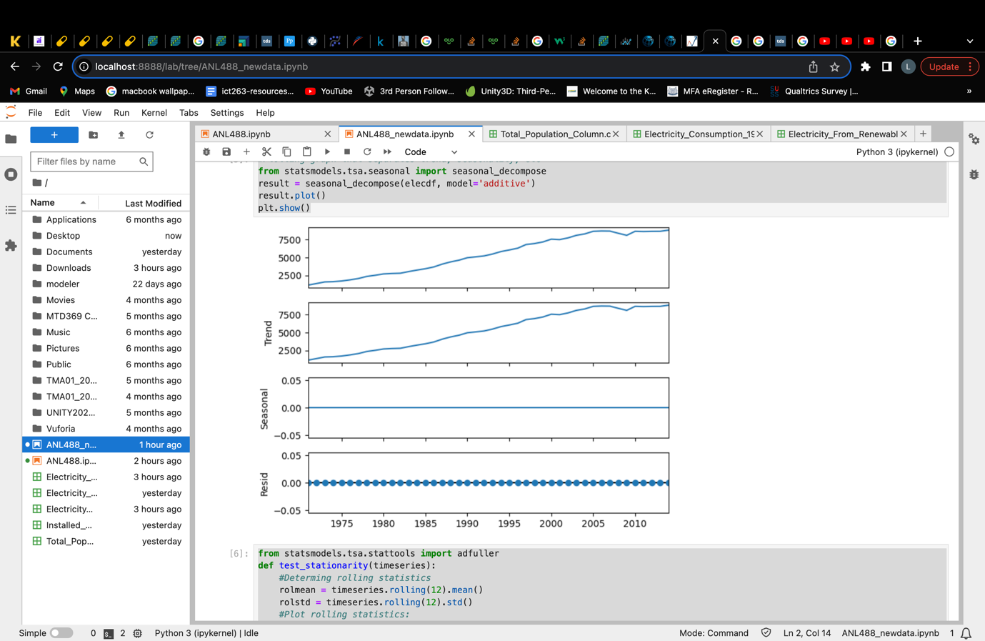

##### *Figure 1.5: Electricity consumption dataset visualisation graph*

Figure 1.5 shows the data presented visually on the left and seasonally decomposed to identify possible trends and seasonality on the right. From here, we can see that the data does consists an upward trend. However, it does not contain seasonality which is expected, as this dataset contains yearly data that will unlikely show seasonality.

Additive decompose was chosen here because the data does not have seasonality, hence, additive decompose would be more suitable as seasonality here does not change in relation to time. (PennState, 2023)

Hence, to remove the trend present, we conducted first order of differencing on the electricity consumption dataset. Differencing is one of the common method used to remove trend from a data. It works by stabilizing the mean of the data series over time by subtracting observations from a previous time period. (Brownlee, 2020) This ensures that the mean of data will not be increasing or decreasing forming a trend, hence removing the possible trend present in data.

|  |  |
| --- | --- |
| P-values **before** differencing | 1.000 |
| P-value **after** 1st First Order Differencing | 0.360 |
| P-value **after** 2nd First Order Differencing | 0.569 |
| P-value **after** 3rd First Order Differencing | 0.000 |

##### *Table 2: Electricity consumption p-value after 1st and 2nd order of differencing*

Table 2 shows the p-value results obtained before and after each order of differencing using both the Augmented Dickey-Fuller (ADF) test. As we previously discussed, the ADF test allows us to reject the null hypothesis of H0 = data **is not** stationary when p-value is <= 0.05 significance value.

After the first order of differencing, the electricity consumption data returns a p-value of 0.360 for ADF test. This shows that the data after first order of differencing is not yet stationary and hence, a second and third order of differencing was performed. After the third order of differencing, the p-value returned is 0.000 that indicates that the data is now stationary as we are able to reject the null hypothesis that this data is not stationary as 0.000 is < 0.05. (The p-values here are only displayed to 3 decimal place)

#### 3) Removing Seasonality

After removing the trend present, seasonality needs to be taken care of. However, as the electricity consumption dataset contains only yearly data, seasonality will not be present. This can be further supported by figure 1.5 where the seasonality in the seasonally decomposed graph on the right shows a straight line. Hence, as seasonality is not present in this data, there will be no need to perform steps to remove seasonality.

#### 4) Ensuring Stationarity

After removing possible trend and seasonality, we have to ensure that the data has indeed achieve stationarity. To do so, a simple ADF test is performed to ensure that the p-value is lower than the significance level of 0.005.

*Checking for stationarity* ***after*** *differencing*

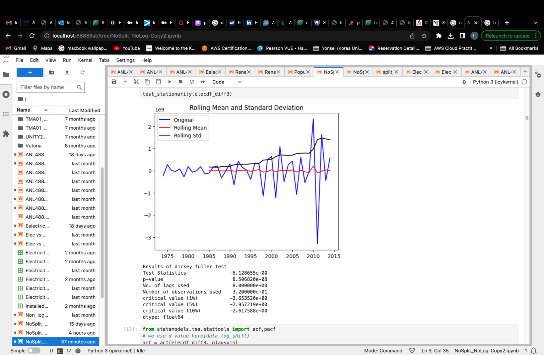

##### *Figure 1.6: Checking electricity consumption dataset for stationarity after 1st order differencing*

Compared to figure 1.4, figure 1.6 visually shows less of a upward trend. The p-value now is also smaller than 0.005 at 0.000002. The test statistics value of -5.465321 is also smaller than all 3 critical values. Hence, this suggests that this data is now stationary and ready for modelling.

The 5 data preparation steps performed above were applied to the next two datasets as well.

### **Singapore’s Renewable Electricity Generated Dataset**

#### 1) Handling missing or null values

|  |  |  |
| --- | --- | --- |
|  | **Before** | **After** |
| **Missing Values** | 33 | 0 |
| **Range of data left** | 1960 to 2022 | 1986 to 2015 |
| **No. of rows left** | 64 | 31 |

*Table 3: Before and after handled missing values in renewable electricity generated dataset*

As missing values amounted to slightly more than 50% of the dataset, missing values in this dataset was attempted to be replaced by mean. However, the data was unable to achieve stationarity as the replacement of the missing values seem to have created biasness in the dataset and causing ADF test’s p-value to shoot up. Hence, missing values will be discarded instead.

The data missing from the time periods may be due to Singapore only generating renewable electricity from 1986 onwards. Missing values from 2016 to 2022 might suggest that they are data not yet collected by the source.

Figure 2.2 in the appendix shows the presence of null values in the dataset. We can also observe that the time element of the data is set to index in python in order to make the dataset applicable for forming a time series model.

After removing the null values from the dataset, the original dataset with 2 columns and 63 rows is reduced to 2 columns and 30 rows of data. It consists of Kilowatts-hour (kWh) of electricity generated from renewable sources in Singapore from years 1986 to 2015.

After dealing with missing values, we will do a simple check on the stationarity of the dataset to determine if the dataset is ready for modelling.

#### 2) Check for stationarity

|  |  |
| --- | --- |
| P-value **before** differencing | 0.993 |

*Table 4: P-value before differencing for renewable electricity generated dataset*

Figure 2.4 in the appendix shows the results of the dickey fuller test conducted to investigate if the dataset is stationary before taking steps to ensure its stationarity. From the results, we can deduce that the dataset is not stationary.

This can be seen firstly, from the visual graph that this data has somewhat an upward trend. This can be seen more clearly in the rolling mean line on the graph.

Secondly, we can deduce stationarity from the p-value generated where it is greater than the significance value 0.005. Thus, we would not reject the hypothesis and this data is thus not stationary.

Lastly, we can also determine if the data is stationary by looking at whether the test statistics value is smaller than the critical values. Here, the test statistics is much bigger than all 3 critical values, hence indicating as well that the data is not stationary.

After deducing that the data has a somewhat trend and is not stationary, we will be using differencing in an attempt to remove the trend present and achieve stationarity for this dataset.

#### 3) Removing trend

Figure 2.5 in the appendix shows the data presented visually (at the top) and seasonally decomposed to identify possible trends and seasonality on the right. From here, we can see that the data does somewhat consists an upward trend especially towards the end of the graph. Seasonality is not see in the graph as expected, because this dataset contains yearly data that will unlikely show seasonality.

|  |  |
| --- | --- |
| P-value **after 1st Order** Differencing  0.00002 | P-value **after 2nd Order** Differencing  0.00000 |

##### *Table 5: Renewable Electricity data p-value after 1st and 2nd order of differencing*

To remove the trend present, we conducted two order of differencing on the renewable electricity generated dataset. Although the p-value obtained after the 1st order of differencing is already <0.05, the data graphically still shows a slight upward trend towards the end of the graph (View figure 2.6). Hence a 2nd order of differencing was performed to bring the upward trend down (view figure 2.7). Table 5 shows the p-value results obtained after the first and second order of differencing using the Augmented Dickey-Fuller (ADF) test. The results showed p-value 0.00002 and 0.0000 for both tests respectively.

This shows that the null hypothesis for the ADF test is rejected. Hence, indicating that the data is now stationary. (The p-values here are only displayed to 5 decimal place)

#### 4) Removing Seasonality

After removing trend, seasonality needs to be removed as well, if applicable. However, as the renewable electricity generated dataset contains only yearly data, seasonality will not be present. This can be further supported by figure 2.5 where the seasonality in the seasonally decomposed graph shows a straight line. Hence, as seasonality is not present in this data, there will be no need to perform steps to remove seasonality.

#### 5) Ensure stationarity

After removing possible trend and seasonality, we now need to ensure that the data has indeed achieve stationarity. To do so, a simple ADF test is performed again to ensure that the p-value of the differenced data is lower than the significance level of 0.005.

Compared to figure 2.4, figure 2.6 visually shows less of a upward trend. And comparing figure 2.6 with 2.7, we can see the upward trend towards the end of the graph is being pulled down in figure 2.7. The p-value now is also smaller than 0.005 and the test statistics value is also smaller than all 3 critical values. Hence, this suggests that this data is now stationary.

### **Singapore’s Total Population Dataset**

#### 1) Handling missing or null values

|  |  |
| --- | --- |
| **Missing Values** | 0 |
| **Range of data left** | 1950 to 2022 |
| **No. of rows left** | 73 |

*Table 6: Missing values present – Population dataset*

Unlike the previous two datasets, this data does not have any null or missing values as can be seen from table 6 and figure 3.1 in the appendix. Hence, this data consisting of 2 columns and 73 rows have no missing data needed to be discarded or replaced.

Figure 3.2 in the appendix shows the step where the time element of the data is set to index in python in order to make the dataset applicable for forming a time series model.

#### 2) Check for stationarity

|  |  |
| --- | --- |
| P-value **before** differencing | 0.999 |

*Table 7: p-value before differencing – population dataset*

Table 7 and figure 3.3 in the appendix shows the results of the dickey fuller test conducted to investigate if the dataset is stationary before taking steps to ensure its stationarity. From the results, we can deduce that the dataset is not stationary.

This can be seen firstly, from the visual graph that this data has an upward trend. As we can see from the upward trending original line as well as the rolling mean line in figure 3.3.

Secondly, we can deduce stationarity from the p-value generated where in this case is greater than the significance value 0.005. Thus, we would not reject the null hypothesis and deduce that this data is not stationary.

Lastly, we can also determine if the data is stationary by looking at whether the test statistics value is smaller than the critical values. Here in figure 3.3, the test statistics is much bigger than all 3 critical values, hence indicating as well that the data is not stationary.

After deducing that the data has a trend and is not stationary, we will be using differencing in an attempt to remove the trend present and achieve stationarity for this dataset.

#### 3) Removing trend

Figure 3.4 in the appendix shows the data visually presented on the left and seasonally decomposed to identify possible trends and seasonality. From there, we can see that the data does consists an upward trend. However, seasonality is not see in the graph as expected, because this dataset contains yearly data that will unlikely show seasonality.

|  |  |
| --- | --- |
| P-value **before** differencing | 0.999 |
| P-value **after 1st Order** Differencing | 0.127 |
| P-value **after 2nd Order** Differencing | 0.002 |

##### *Table 8: Total Population data p-value after first and second order of differencing*

To remove the trend present, we conducted first and second order of differencing on the total population dataset. Table 8 shows the p-value results obtained before and after the first and second order of differencing using the Augmented Dickey-Fuller (ADF) test.

As observed from table 8, the p-value after the first order of differencing was 0.127. As the p-value is still larger than 0.005, the p-value for the ADF test still suggests that the data is not stationary. Hence, a second order of differencing is performed to further de-trend the data. After the second differencing, the p-value for the ADF test successfully became smaller than 0.005 at 0.002, suggesting that the data is now stationary. (The p-values here are only displayed to 3 decimal place)

#### 4) Removing Seasonality

After the trend is removed, seasonality needs to be removed as well, if applicable. However, as the total population dataset contains only yearly data, seasonality will not be present. This can be further supported by figure 3.4 where the seasonality in the seasonally decomposed graph on the right shows a straight line. Hence, as seasonality is not present in this data, there will be no need to perform steps to remove seasonality.

#### 5) Ensure stationarity

After removing possible trend and seasonality, we now need to ensure that the data has indeed achieve stationarity. To do so, a simple ADF test is performed again to ensure that the p-value of the differenced data is lower than the significance level of 0.005.

This can be seen from table 8 where a p-value of <0.05 is obtained from the twice differenced data.

Compared to figure 3.3, figure 3.5 visually also shows less of an upward trend where most values now lies around the 0 point. The p-value now is also smaller than 0.005 at 0.002. The test statistics value of -3.857682 is also smaller than all 3 critical values. Hence, this suggests that this data is now stationary.

# **Modelling and Evaluation**

As our study focuses on time series analysis, models such as Single (SES), double (Holt’s) and triple exponential smoothing (Holt-winter’s), AR, MA, ARIMA, ARMA, SARIMA and SARIMAX are considered. However, as our data does not contain seasonality, models specialising in seasonality such as Holt-winter’s method, SARIMA and SARIMAX would be ruled out of this study. Single exponential smoothing used for dataset with no trend and seasonality will also be ruled out of this study as our dataset shows signs of trend present. (Otext, 2023) The ARMA model will also be ruled out as differencing was conducted on all 3 datasets in order for all data to be stationary, hence ARMA which works better on stationary datasets would be ruled out as our datasets were non-stationary to begin with. (Mills, 2019) Both the AR and MA models will not be studied as standalone models in this study as the ARIMA model containing both the AR and MA model will be used instead. Hence, this study will focus on 2 models namely, the ARIMA model and Double Exponential Smoothing (Holt’s) method.

## *ARIMA MODEL*

An Auto-regressive integrated moving average (ARIMA) model is the most general model used in time series forecasting. It forecasts future values by using forecast errors and/or past values. (Lianne & Justin, 2022) This model works best if data is stationary, with no seasonality with one variable (univariate). (*Univariate time series analysis*, 2022) Hence, this modelling technique will be a great candidate for our datasets.

An ARIMA model is made up of three components namely:

1. Autoregression (AR)
2. Differencing (I)
3. Moving Average (MA)

These three components make up an ARIMA model where it is presented as ARIMA(p, d, q). The p represents the AR model which indicates autoregressive term, d represents the number of time the data was differenced and q represents the MA model which indicates the number of moving averages or error terms. (linkedin, 2023)

The order of the ARIMA model will be determined based on the model’s ACF, order of differencing performed and PACF. These will determine the ARIMA model’s p, d, q values respectively.

Hence, a PACF and ACF plot would be produced for each dataset to manually determine a suitable order of ARIMA model before model construction.

## *DOUBLE EXPONENTIAL SMOOTHING (HOLT’S) METHOD*

As an extension from single exponential smoothing (SES), the Holt’s method also known as double exponential smoothing builds on the SES model by adding a trend smoothing component. (Brownlee, 2020) It is useful in predicting data without seasonality but with trend which is perfect since our datasets exactly contains only trend, without seasonality.

The hyperparameters in this model includes:

* Alpha: Smoothing the level of the data
* Beta: Smoothing the trend of the data
* Trend Type: Additive / Multiplicative
* Dampen Type: Additive / Multiplicative
* Phi: Damping Coefficient

To determine which model would be finalised, a comparison of the various model’s accuracy and performance based on their MAPE and R Square values are done to determine which model is the best fit for the respective dataset.

The Mean Absolute Percentage Error (MAPE) value helps us to evaluate the model’s performance based on the % of error the model has. It is essentially the average absolute percentage difference between the actual and predicted values and hence, a smaller MAPE value would suggest a better performing model. (Allwright, 2022)

R Square value determines how well a data fits the model and is a statistical measure that defines the variance proportion of the dependant variable that can be explained by the independent variable. (Taylor, 2023) R square value ranges between 0 to 1 where the higher the value the better fit as it would indicate that more variability present in the data can be explained by the model.

The following are the various model’s results for each dataset.

**Singapore’s Electricity Consumption Dataset**

ARIMA MODEL

In order to determine what ARIMA model to use, we first have to determine the p, d, and q values for this dataset. Firstly, to determine the d value, we have to take note the number of times the dataset was differenced till it reaches stationarity. Here, the dataset was differenced a total of 2 times as shown below.

|  |  |
| --- | --- |
| **Order of differencing** | **P-value** |
| After 1st order | 0.360 |
| After 2nd order | 0.569 |
| After 3rd order | 0.000 |

*Table 9: ARIMA model order of differencing determination – Electricity Consumption data*

Table 9 provides an overview of the p-value for each order of differencing performed on the electricity dataset to achieve stationarity with p-value less than 0.05.

From figure 4.1, we can see that the p-value is 0.36 which is bigger than 0.05. Hence, we cannot reject the null hypothesis that the data is not stationary, and thus the dataset is still not stationary. We can also visually observe that the graph has a slight decreasing trend which also suggests that it is not yet stationary. However, after differencing the second time, we can visibly see from figure 4.2 that the graph is showing less of a trend and the values now ranges around the 0 mark. However, the p-value 0.596 was still bigger than 0.05 which suggests that this dataset is still not stationary after the second order of differencing. Hence a third order of differencing is performed on this dataset. The p-value then becomes 0.00 (3dp of 8.506820e-08) which is smaller than 0.05. Hence we can now reject the null hypothesis that the dataset is not stationary and conclude that the dataset is now stationary.

Next, to determine both p and q values, we can look at the ACF and PACF plot of the differenced dataset.

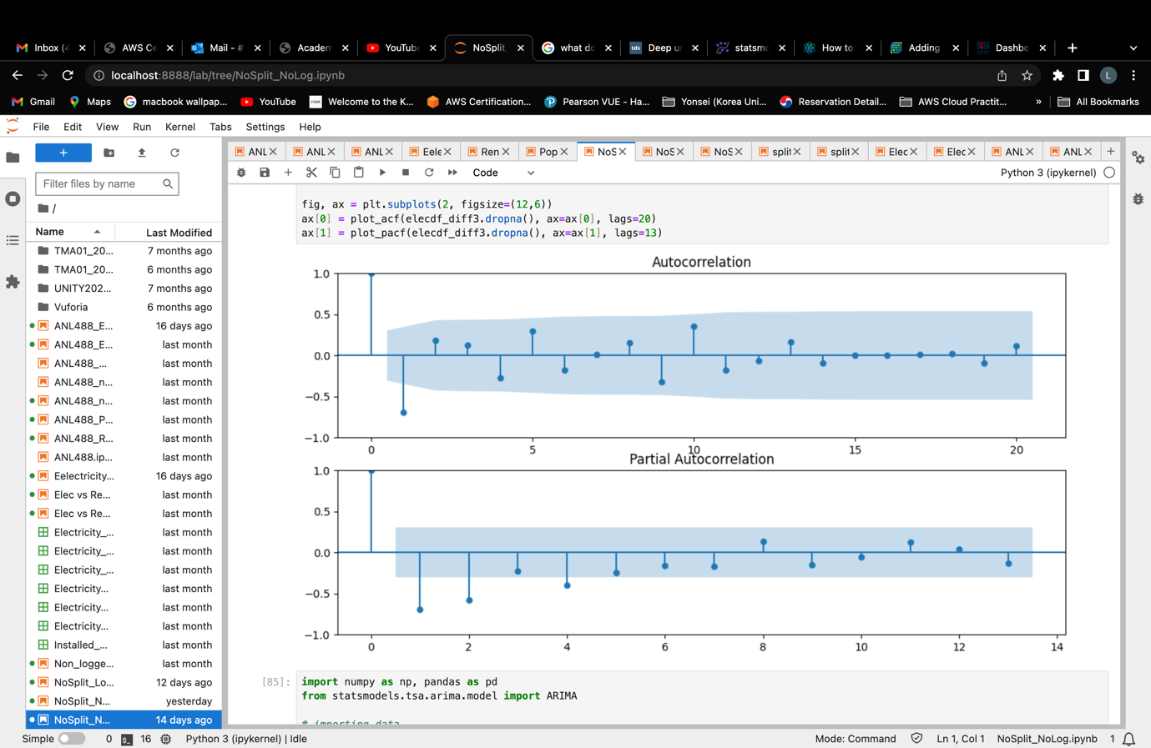

*Figure 4.4: ACF and PACF plots for Electricity consumption dataset*

From figure 4.4, we can see that in the ACF graph, only lag 1 falls outside the grey-blue area which shows that lag 1 in the ACF plot is significant. However, because lag 1 in the ACF plot is negative and smaller than -0.05, this is potentially a sign of slight over-differencing. Hence, a MA(q) term will be added to the model to counter the slight over-differencing present. Hence, the q value here will be 2.

The PACF graph here has lags 1 and 2 that fall significantly out of the grey-blue area before cutting off. These significant lags from the ACF plot helps to determine the p value while the significant lags in the PACF graph determines the p value in an ARIMA(p,d,q) model.

Hence, we will be comparing the Akaike's Information Criterion (AIC) value of an ARIMA(1,3,2) and ARIMA(2,3,2) model to determine which ARIMA model will be best suited for this dataset.

|  |  |
| --- | --- |
| **Model** | **AIC value** |
| ARIMA(1,3,2) | 1746.456 |
| ARIMA(2,3,2) | 1743.005 |

*Table 10: ARIMA model comparison table – Electricity Consumption dataset*

The Akaike's Information Criterion (AIC) helps to determine how well-fitted a model is to the data. (Smigel, 2023) The smaller the AIC value, the better fitted the model is. If a model’s AIC value is 2 or more lower than the other, this would mean that it is significantly better. Hence, from here, we will be comparing the 2 model’s AIC values in table 10, generated from the ARIMA model summaries from figure 4.5 and 4.6 in the appendix.

According to table 10, we can see that the ARIMA(2,3,2) model has a smaller AIC value compared to the ARIMA(1,3,2) model. The AIC of the ARIMA(2,3,2) model is lower by more than 2 compared to the ARIMA(1,3,2) model. Hence, the best ARIMA model based on their AIC value will be ARIMA(2,3,2) and this ARIMA model will be used for this dataset. Please refer to figure 4.5 and 4.6 in the appendix for full model summary.

Below is the forecasting results using ARIMA(2,3,2) model.

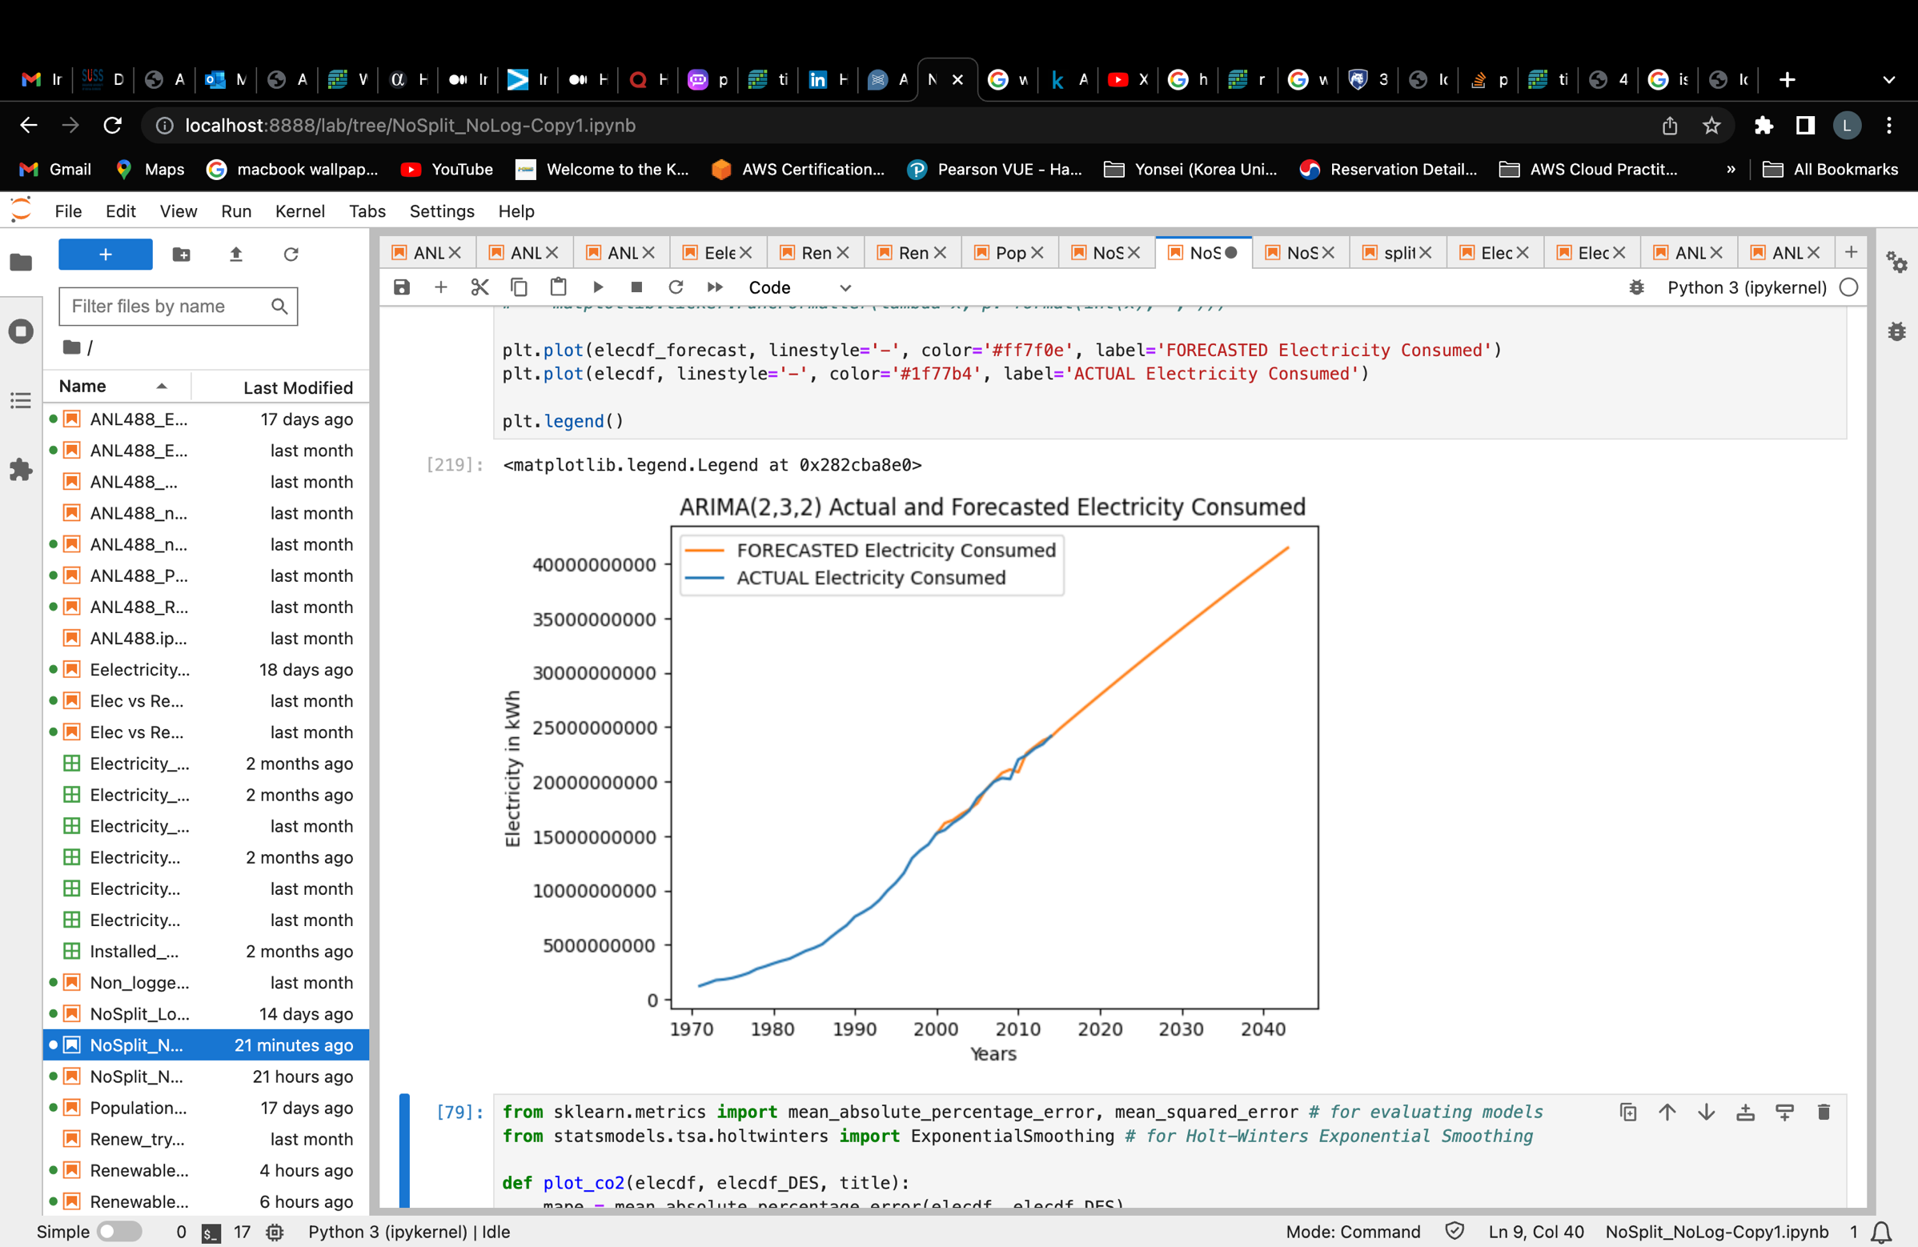

*Figure 4.7: Forecasting results using ARIMA(2,3,2) model*

Figure 4.7 shows us the forecasted results using an ARIMA(2,3,2) model. From the results, we can see that electricity consumption in the future will likely increase at a linearly steep pace.

HOLT’S METHOD

Double exponential smoothing (Holt’s method) is also implemented on this set of dataset to find the better fitting model. The smoothing level (alpha) and smoothing trend (beta) are both set at 0.5 value.

Below is the forecasting result using the Double Exponential Smoothing method.

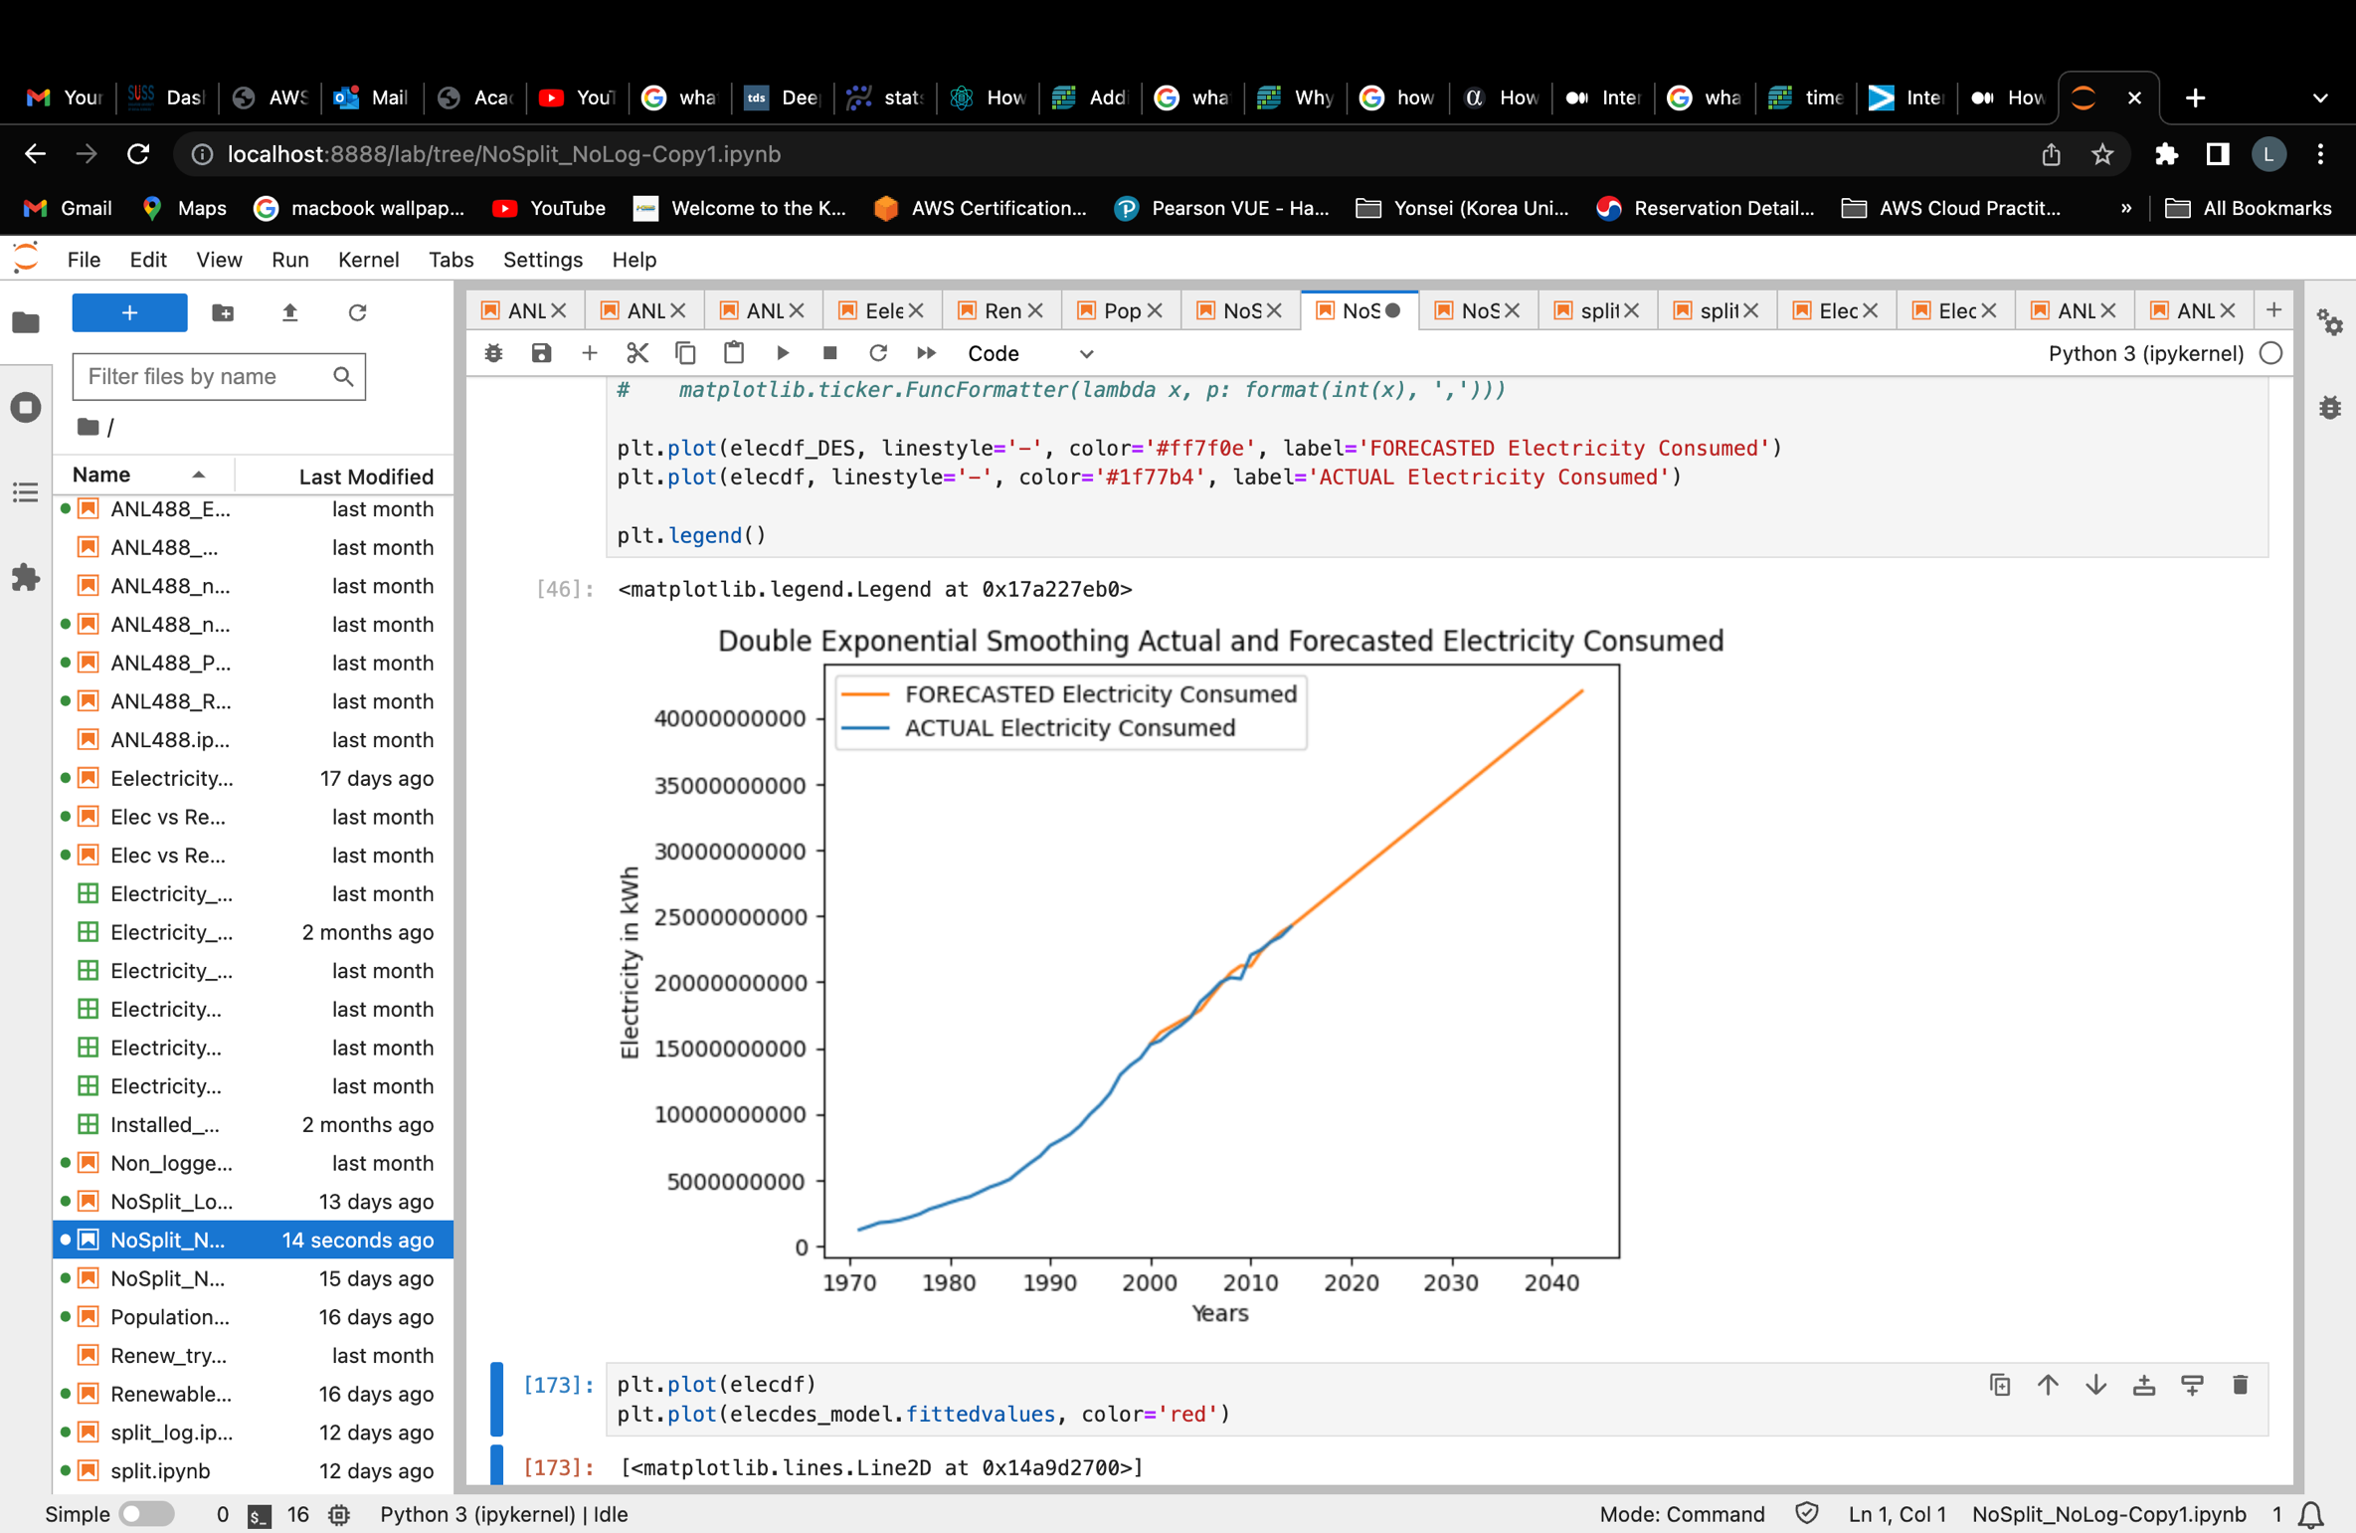

*Figure 4.8: Forecasting Results using Double Exponential Smoothing (Holt’s Method) on Electricity consumption dataset*

Figure 4.8 also shows a linearly steep increase in the consumption of electricity in the future using the Holt’s method model. Hence, it seems like both the ARIMA and Holt’s method predicts that the electricity consumption levels in Singapore will continue to rise in the future.

Let us now determine which model is a better performing with this dataset.

## ***Model Comparison Table***

|  |  |  |
| --- | --- | --- |
| Models | MAPE | R Square |
| ARIMA(2,3,2) | 0.081 | 0.996 |
| Holt’s Method (DES) | 0.026 | 0.998 |

*Table 11: Electricity Consumption data model comparison table*

Here, we can see that the Holt’s Method model is a better fit for this dataset as the MAPE is smaller and the R Square value is greater than the ARIMA model. Hence, for the Electricity consumption dataset, Holt’s method is the winner model.

### **Singapore’s Renewable Electricity Generated Dataset**

ARIMA MODEL

This dataset went through a total of 2 order of differencing.

|  |  |
| --- | --- |
| **Order of differencing** | **P-value** |
| After 1st order | 0.00002 |
| After 2nd order | 0.00000 |

*Table 12: ARIMA model order of differencing determination – Renewable Electricity data*

In figure 4.9, we can see that after the 1st order of differencing, the p-value was already less than 0.05 which likely indicates that the dataset was already stationary. However, graphically looking at the data, we can see that there was still a slight upward trend towards the end of the graph. This likely indicates that the data might be slightly under-differenced. Hence, a second order of differencing was performed to de-trend the data further. In figure 5.0, we can see that the data is now completely flat and de-trended.

Next, to determine the rest of the values needed in an ARIMA model, we have to look at the ACF and PACF plots to determine the p and q values.

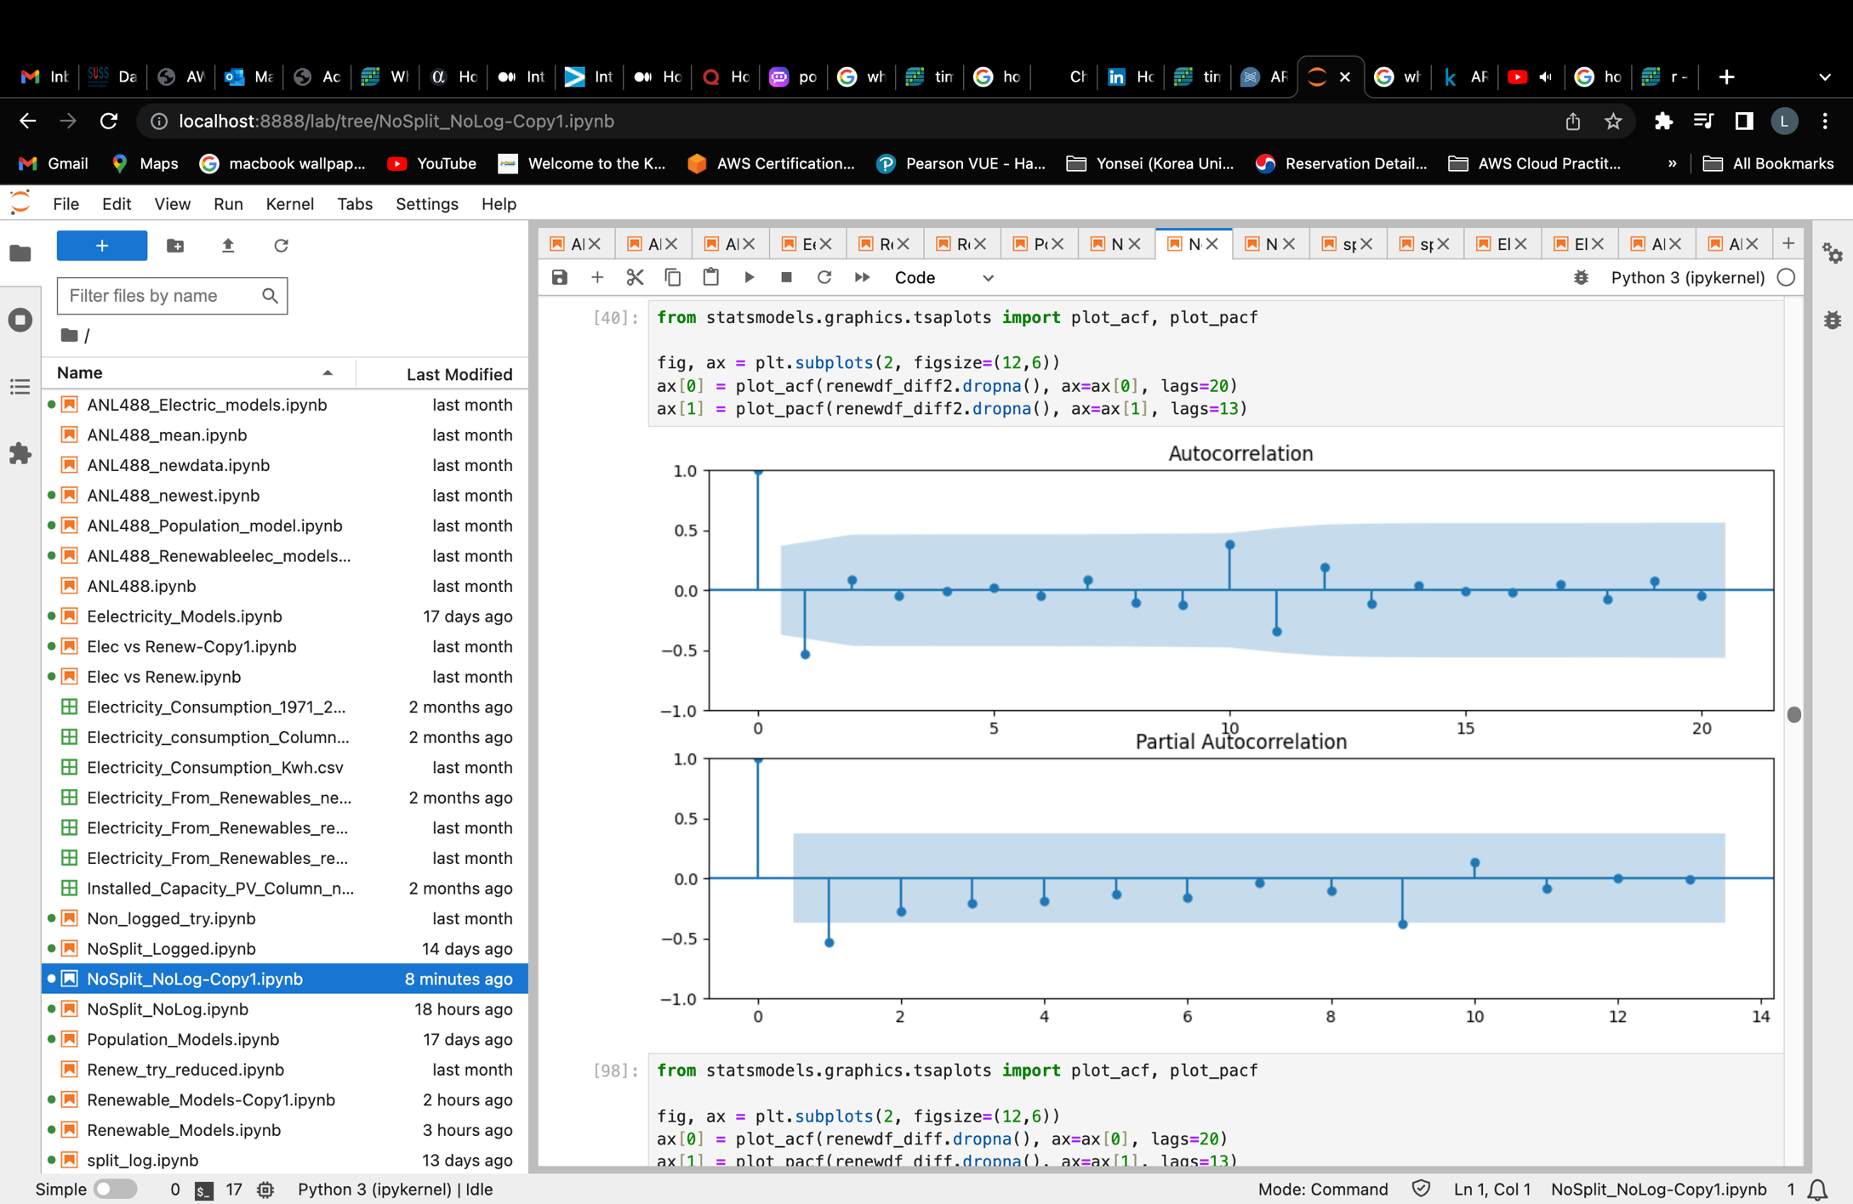

*Figure 5.1: ACF and PACF plots for Renewable Electricity Generated Dataset*

Figure 5.1 shows the ACF and PACF plots of the differenced dataset. We can see that for both the ACF and PACF plot, lag 1 lies significantly outside the blue area indicating that this lag is significant. Hence, the p and q value of an ARIMA(p,d,q) model will be 1.

|  |  |
| --- | --- |
| **Model** | **AIC value** |
| ARIMA(1,2,1) | 1086.432 |

*Table 13: AIC value for ARIMA(1,2,1) model*

Table 13 shows the AIC value for ARIMA(1,2,1) which is the only ARIMA model derivable from the ACF and PACF graph as no other lags lie significantly outside the grey-blue area. We can see that this ARIMA model has an AIC value of 1086.432. Please refer to figure 5.2 for the complete model summary for ARIMA(1,2,1) model.

Below is the forecasted results generated from the ARIMA(1,2,1) model.

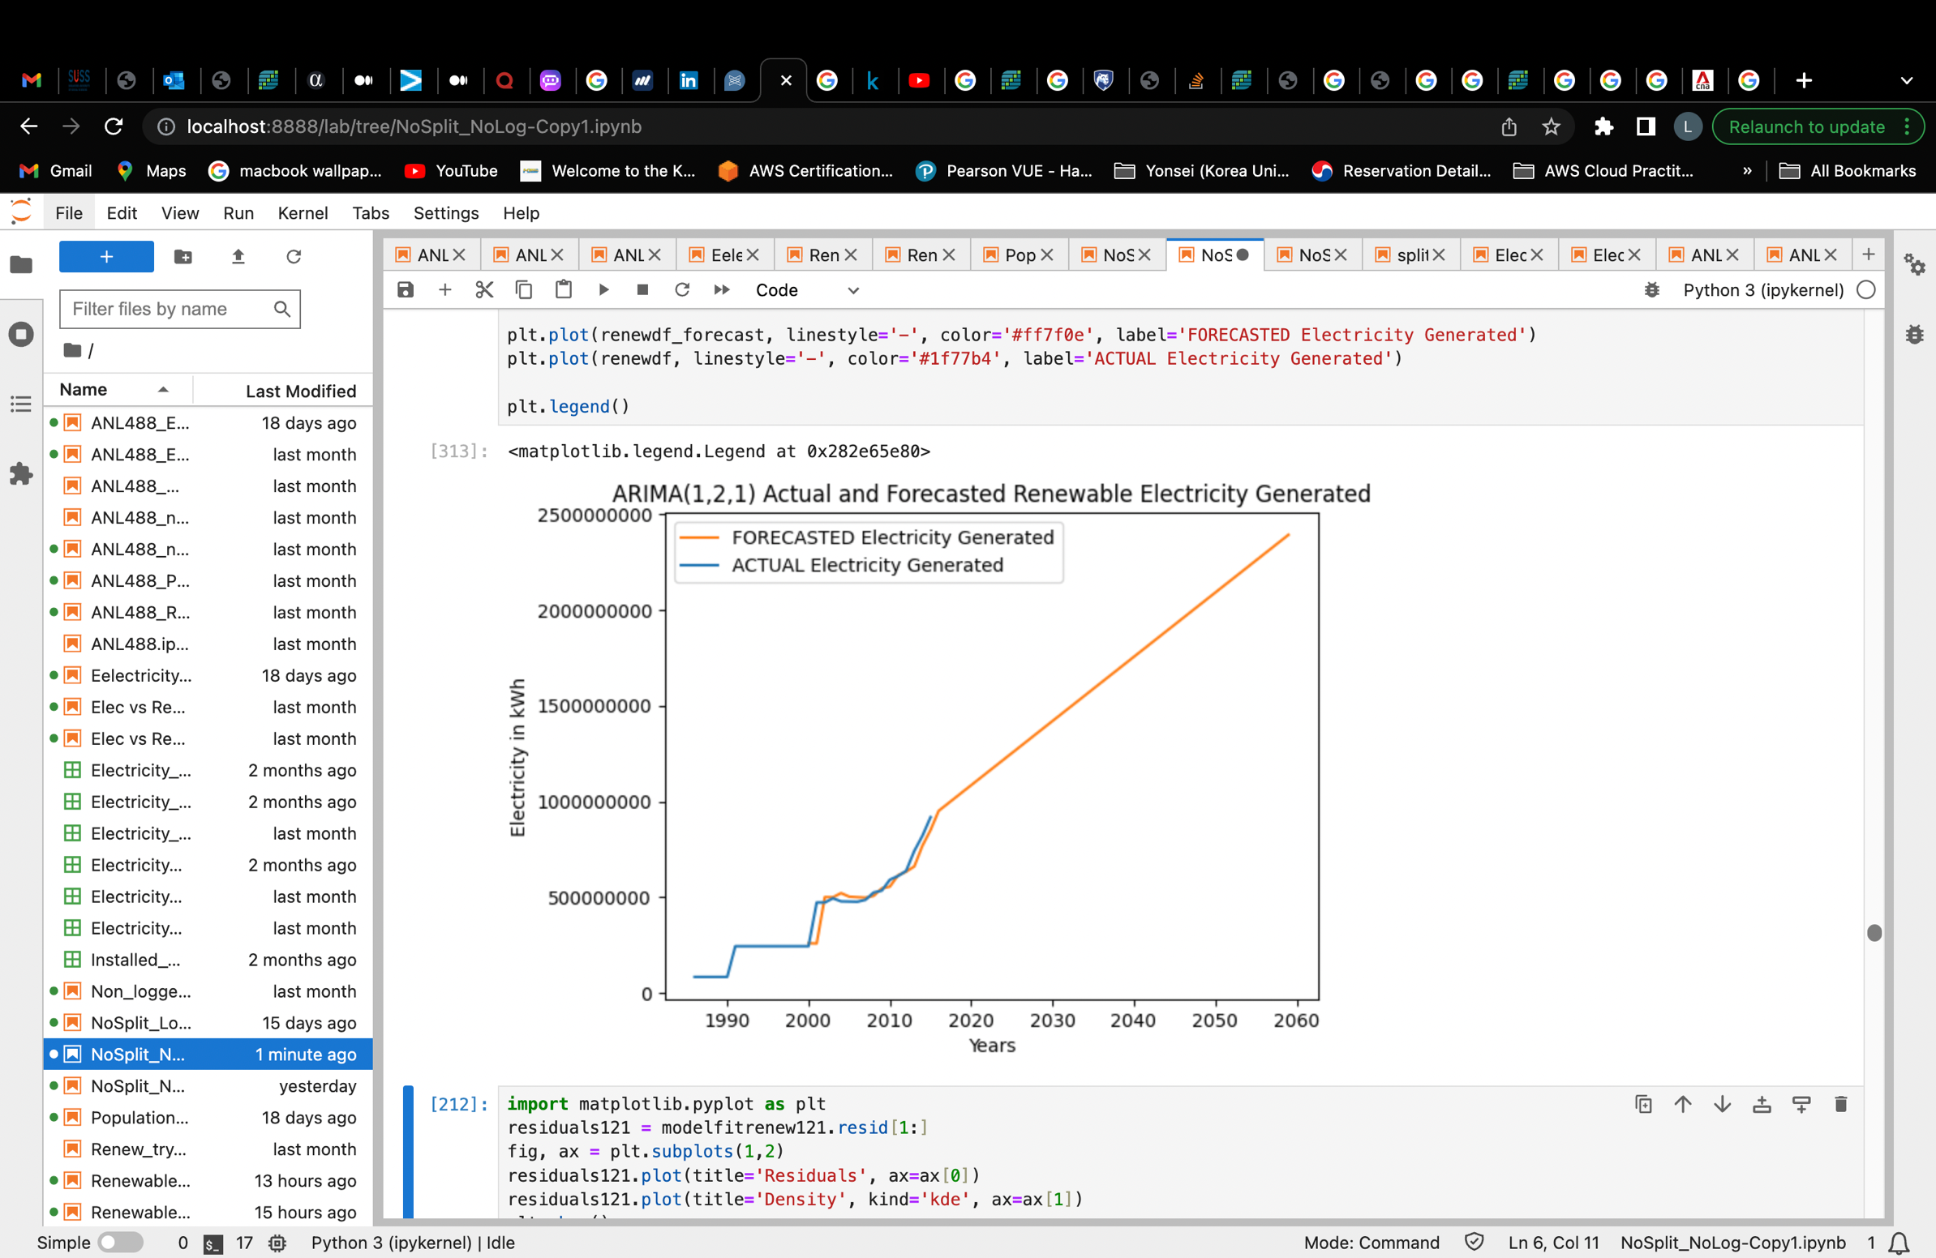

*Figure 5.3: Renewable electricity generated dataset forecasting result using ARIMA(1,2,1) model*

Figure 5.3 shows the forecast results of the renewable electricity generated dataset using the ARIMA(1,2,1) model. The renewable electricity generated level in Singapore is predicted to steadily increase according to this ARIMA model.

HOLT’S METHOD

Double exponential smoothing was also applied on this dataset for comparison to find a better fit for the dataset. The smoothing level (alpha) and smoothing trend (beta) for this Holt’s model is both set to 0.5. Below is the forecasting results of the dataset using double exponential smoothing method.

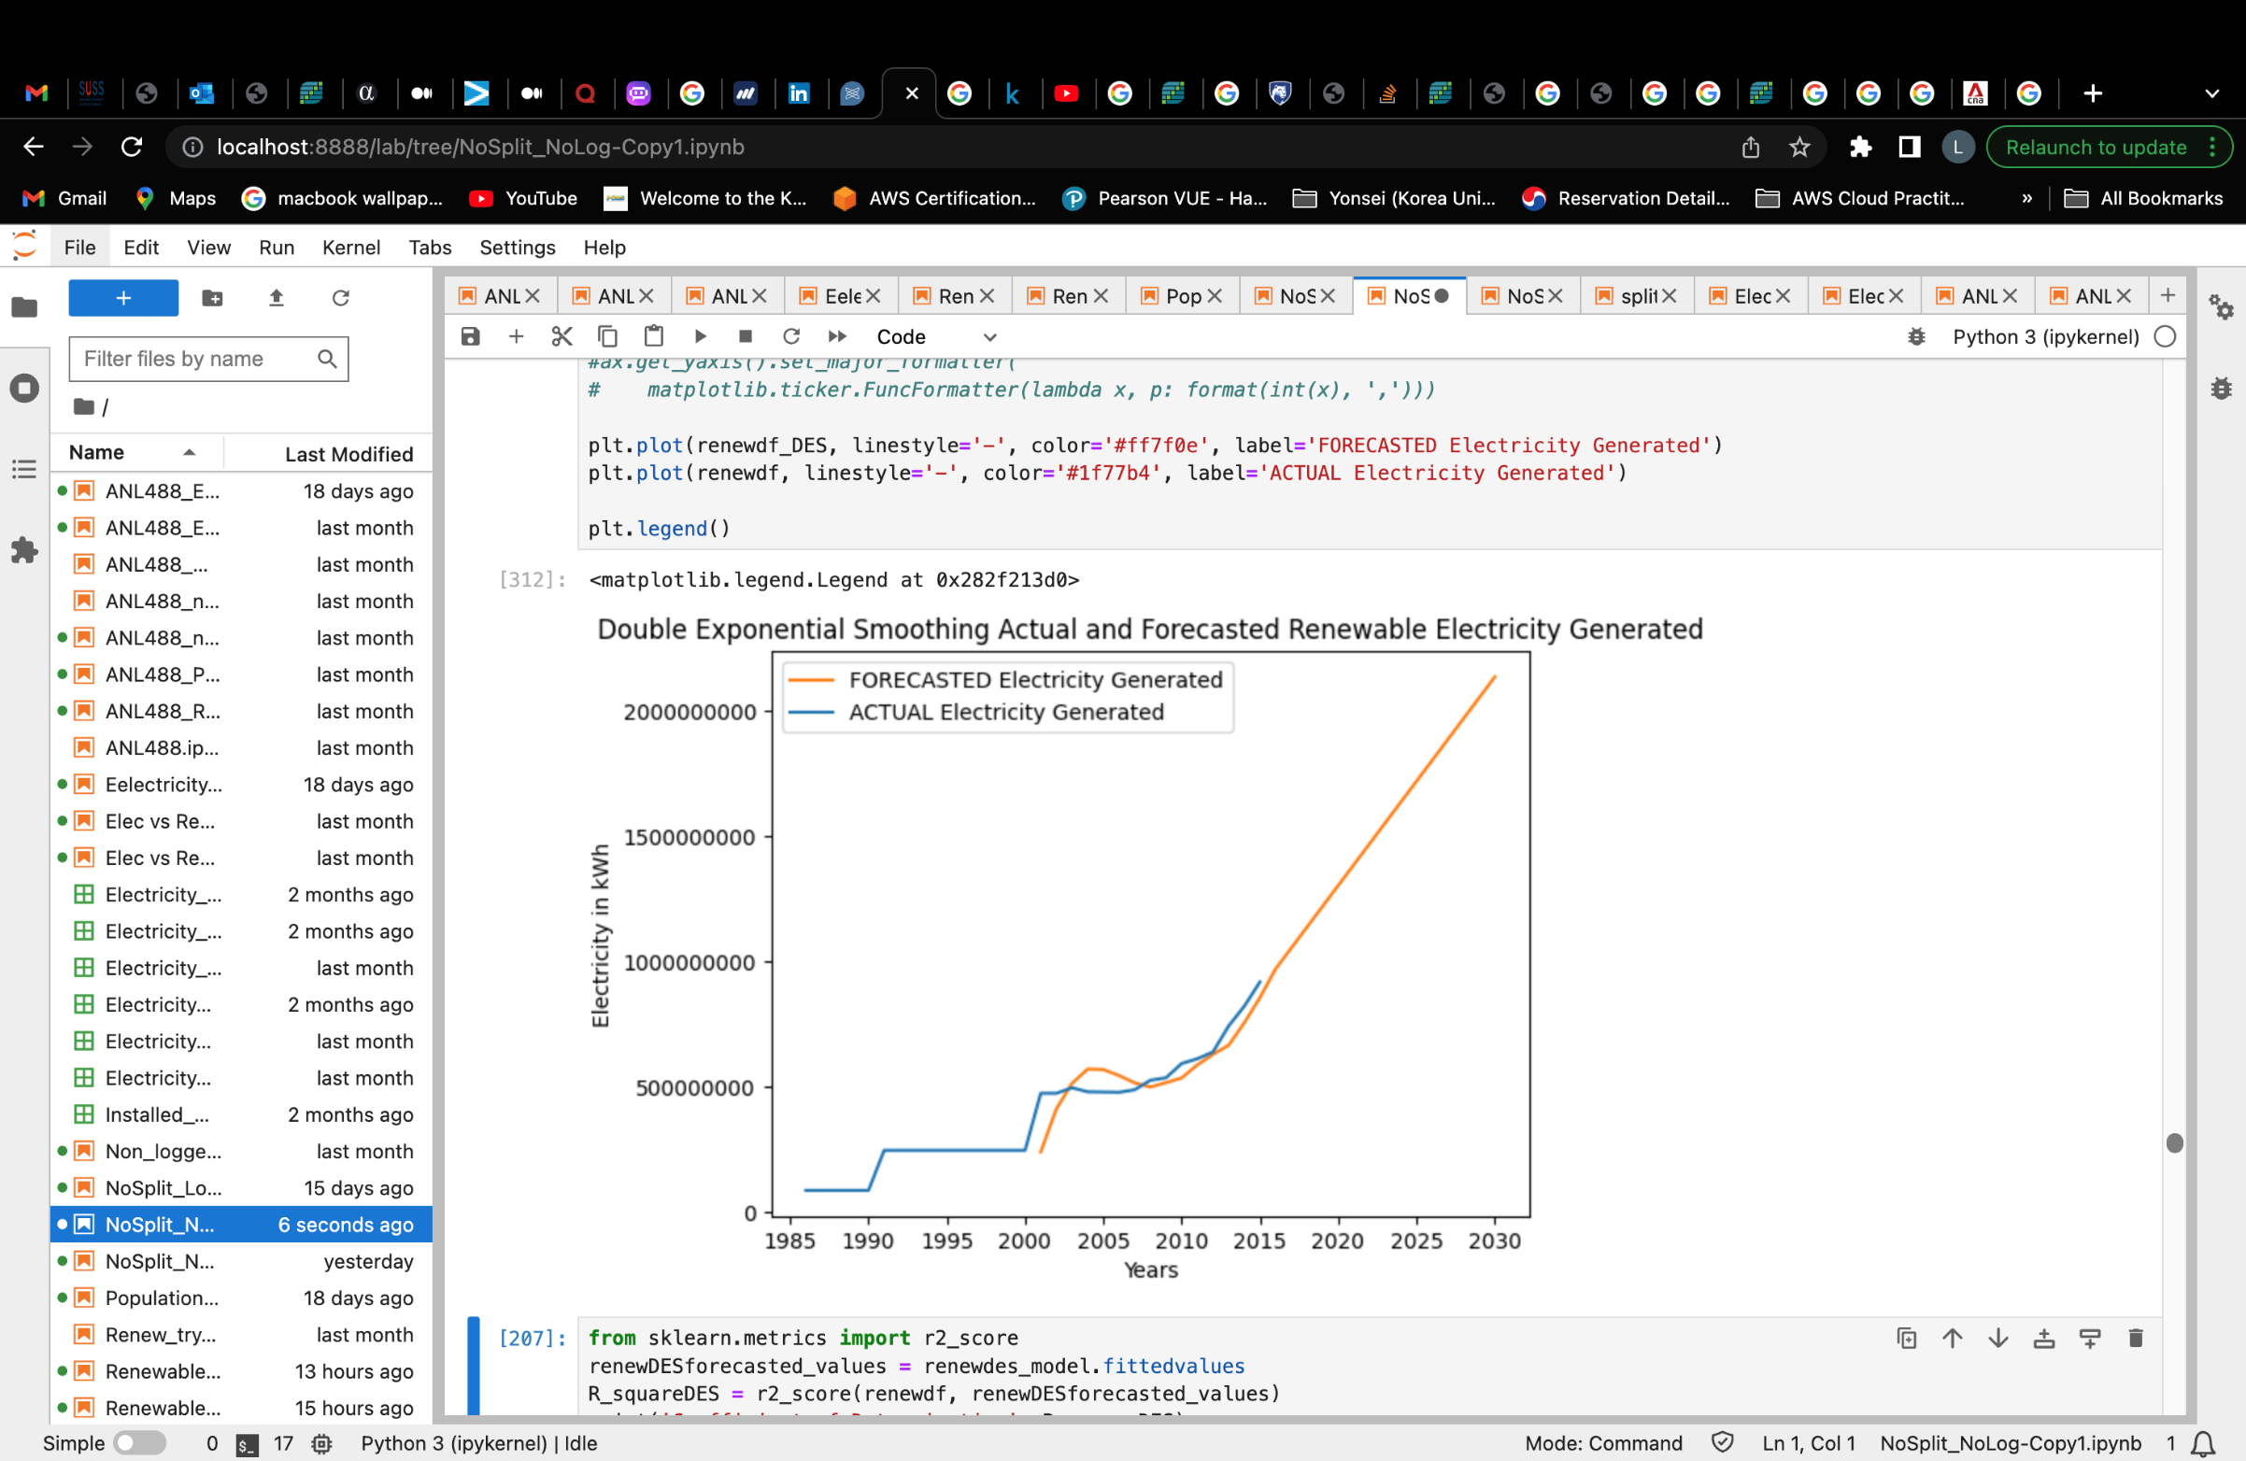

Figure 5.4: *Renewable electricity generated dataset* *forecasting result using Holt’s Method*

Figure 5.4 shows the forecast result using the Holt’s method. Here, the Holt’s method also predicts an increase in the renewable electricity generated in the future.

## ***Model Comparison Table***

|  |  |  |
| --- | --- | --- |
| Models | MAPE | R Square |
| ARIMA(1,2,1) | 0.16 | 0.932 |
| Holt’s Method (DES) | 0.17 | 0.911 |

*Table 14: Renewable Electricity Dataset model comparison table*

From table 14 above, we can see that both the MAPE and R square value of the ARIMA model is better compared to the Holt’s method as the MAPE is smaller and R square value is greater for the ARIMA model. This indicates that the ARIMA model is a better fit for this dataset, Hence, the ARIMA(1,2,1) model will be used for this dataset.

### **Singapore’s Total Population Dataset**

ARIMA MODEL

In order the ensure the data is stationary, 2 order of differencing was performed before the p-value becomes less than 0.05. Hence, this determines the d value of the ARIMA(p,d,q) model.

|  |  |
| --- | --- |
| **Order of differencing** | **P-value** |
| After 1st order | 0.127 |
| After 2nd order | 0.002 |

*Table 15: ARIMA model order of differencing determination – Population Dataset*

Table 15 shows the p-value of the population dataset after each order of differencing. This dataset went through a total of 2 order of differencing to bring the p-value down to smaller than 0.05 which was achieved after the 2nd order of differencing. Hence, the d value in an ARIMA(p,d,q) model would be 2 for the ARIMA models in this dataset.

Please refer to figure 5.5 and 5.6 in the appendix for derivation of the respective p-values.

Next, to determine the p and q values in an ARIMA model, we have to look at the ACF and PACF plots of the dataset.

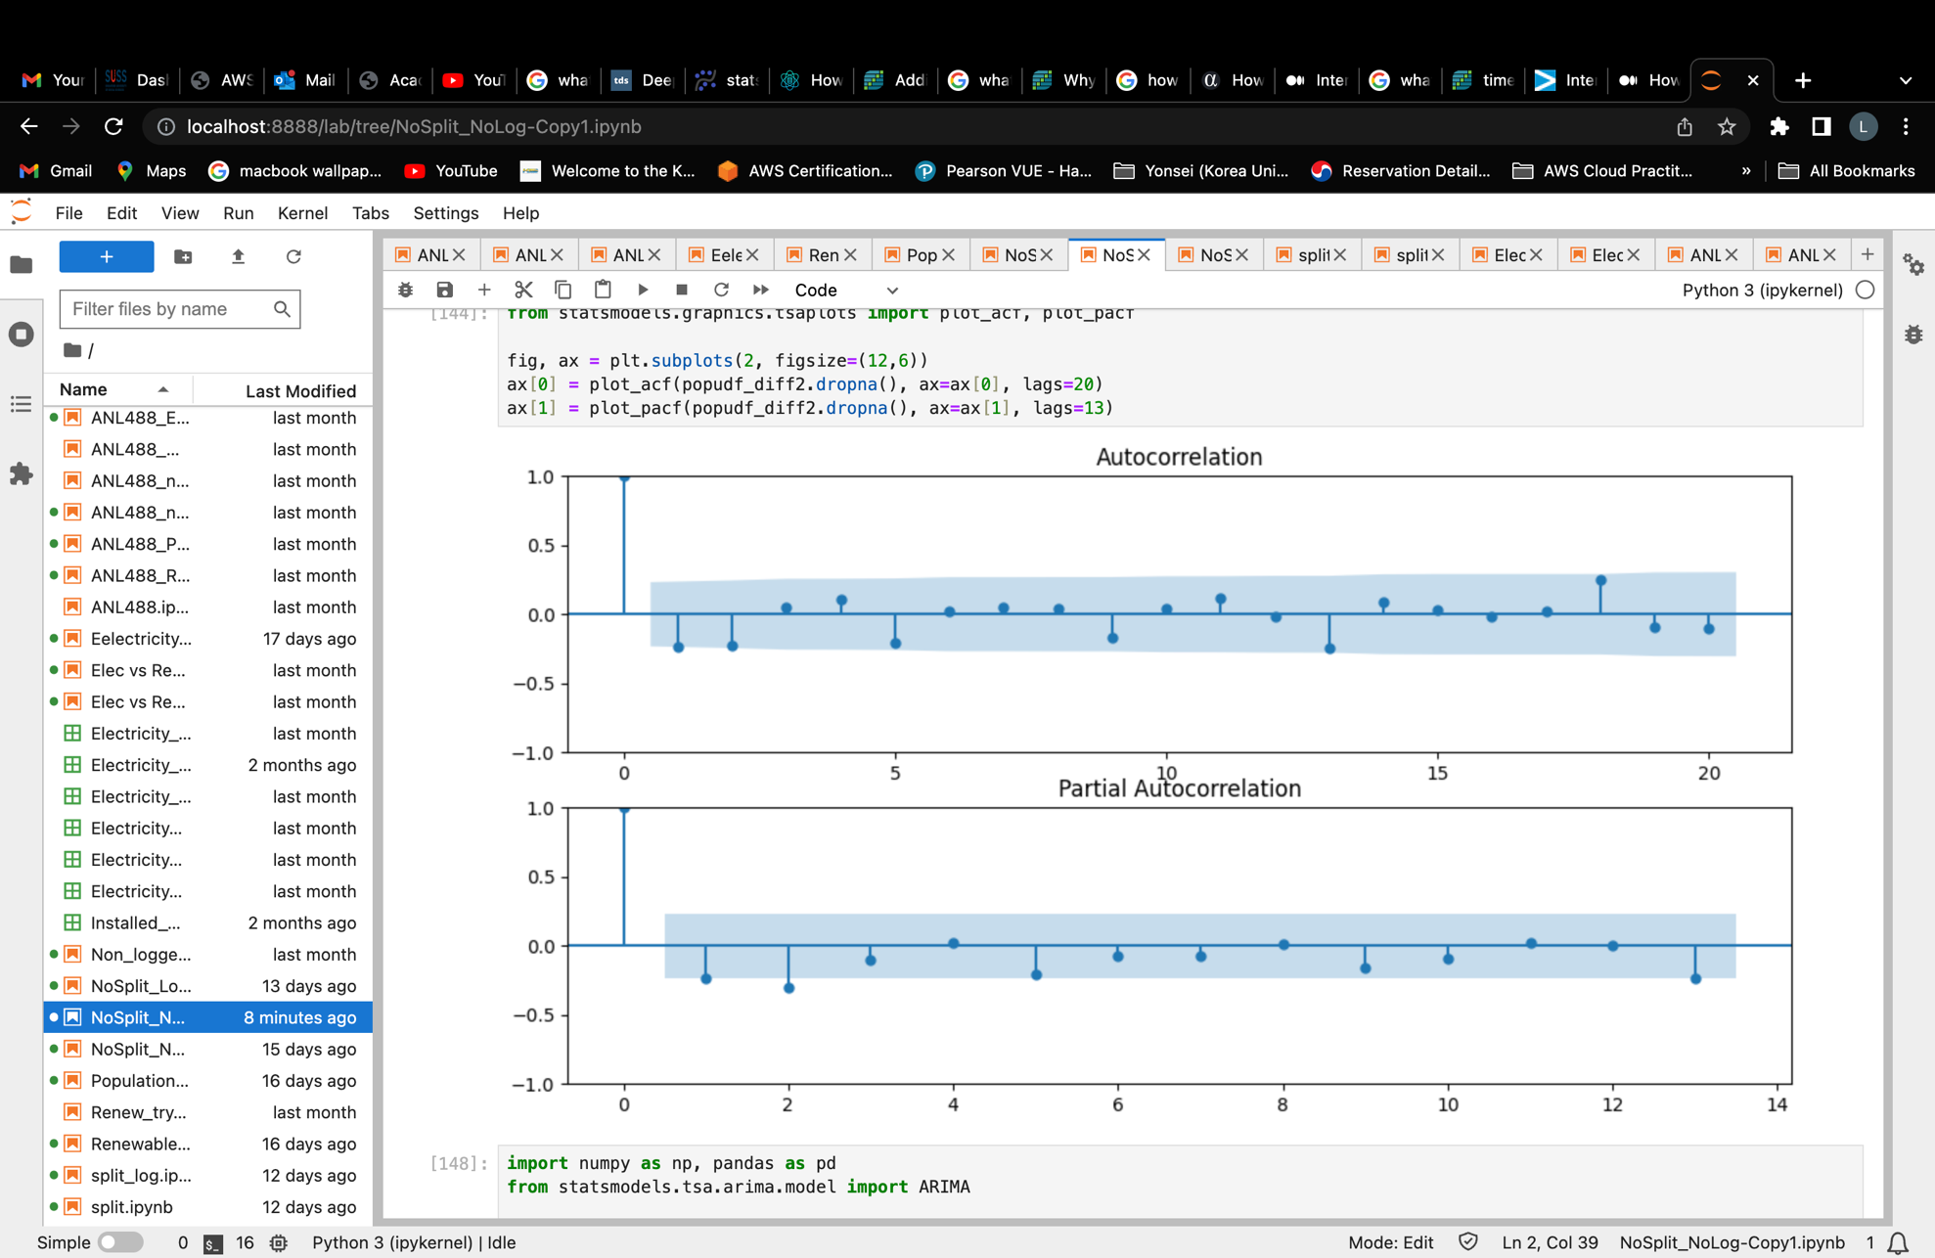

*Figure 5.7: ACF and PACF plots for Total Population Dataset*

From figure 5.7, we can see that lags 1 and 2 lies slightly outside the grey-blue area in the ACF plot. This indicates these lags might be significant and will be considered as the p value of the ARIMA model. The PACF plot also shows lag 1 and 2 slightly outside the grey-blue area. Hence, we will also be using 1 and 2 as the values of d of an ARIMA(p,d,q) model.

Next, we will be comparing the AIC value of models ARIMA(1,2,1), ARIMA(1,2,2), ARIMA(2,2,1) and ARIMA(2,2,2) to determine the best ARIMA model order for this dataset.

|  |  |
| --- | --- |
| **Model** | **AIC value** |
| ARIMA(1,2,1) | 1771.972 |
| ARIMA(1,2,2) | 1773.926 |
| ARIMA(2,2,1) | 1772.950 |
| ARIMA(2,2,2) | 1775.133 |

*Table 16: ARIMA model comparison table – Total Population dataset*

Figure 5.8, 5.9, 6.0 and 6.1 in the appendix shows the respective model’s summary. From the consolidated table 16, we can see that ARIMA(1,2,1) model had the smallest AIC value. This means that ARIMA(1,2,1) model would be the better model for this dataset compared to the other 3 models. Hence, we will be using ARIMA(1,2,1) as the ARIMA model for this dataset.

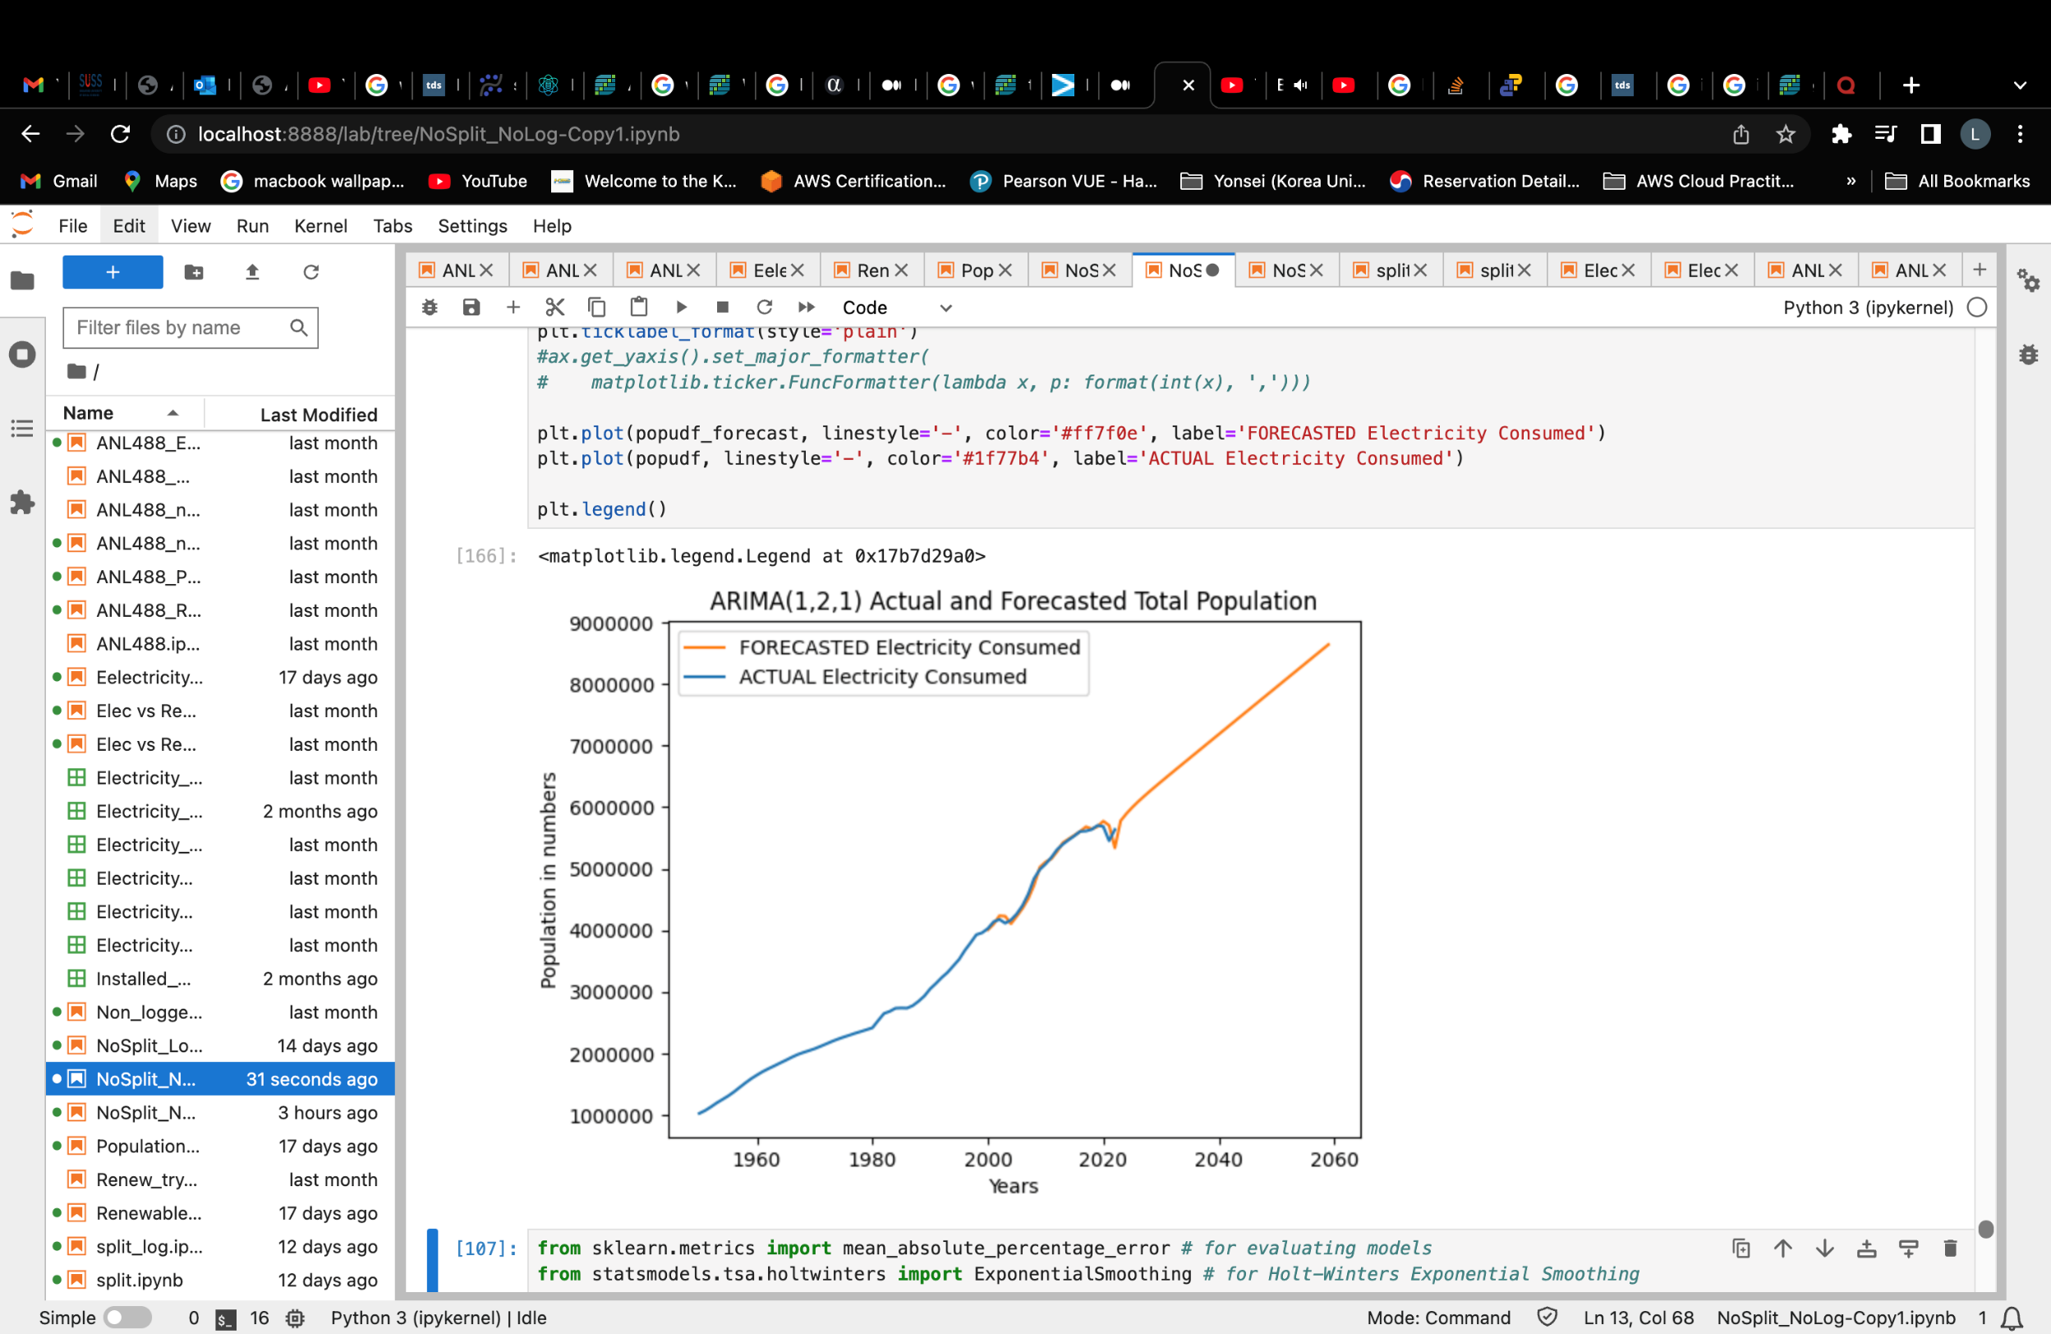

*Figure 6.2: Total Population dataset forecasting result using ARIMA(1,2,1) model*

Figure 6.2 shows the forecasting results of the total population dataset using the ARIMA(1,2,1) model. We can see that the nation’s population was forecasted to steadily increase in the future using the ARIMA(1,2,1) model.

HOLT’S METHOD

The smoothing level (alpha) and smoothing trend (beta) for this Holt’s model is both set to 0.5. Below is the forecasting results of the dataset using double exponential smoothing method.

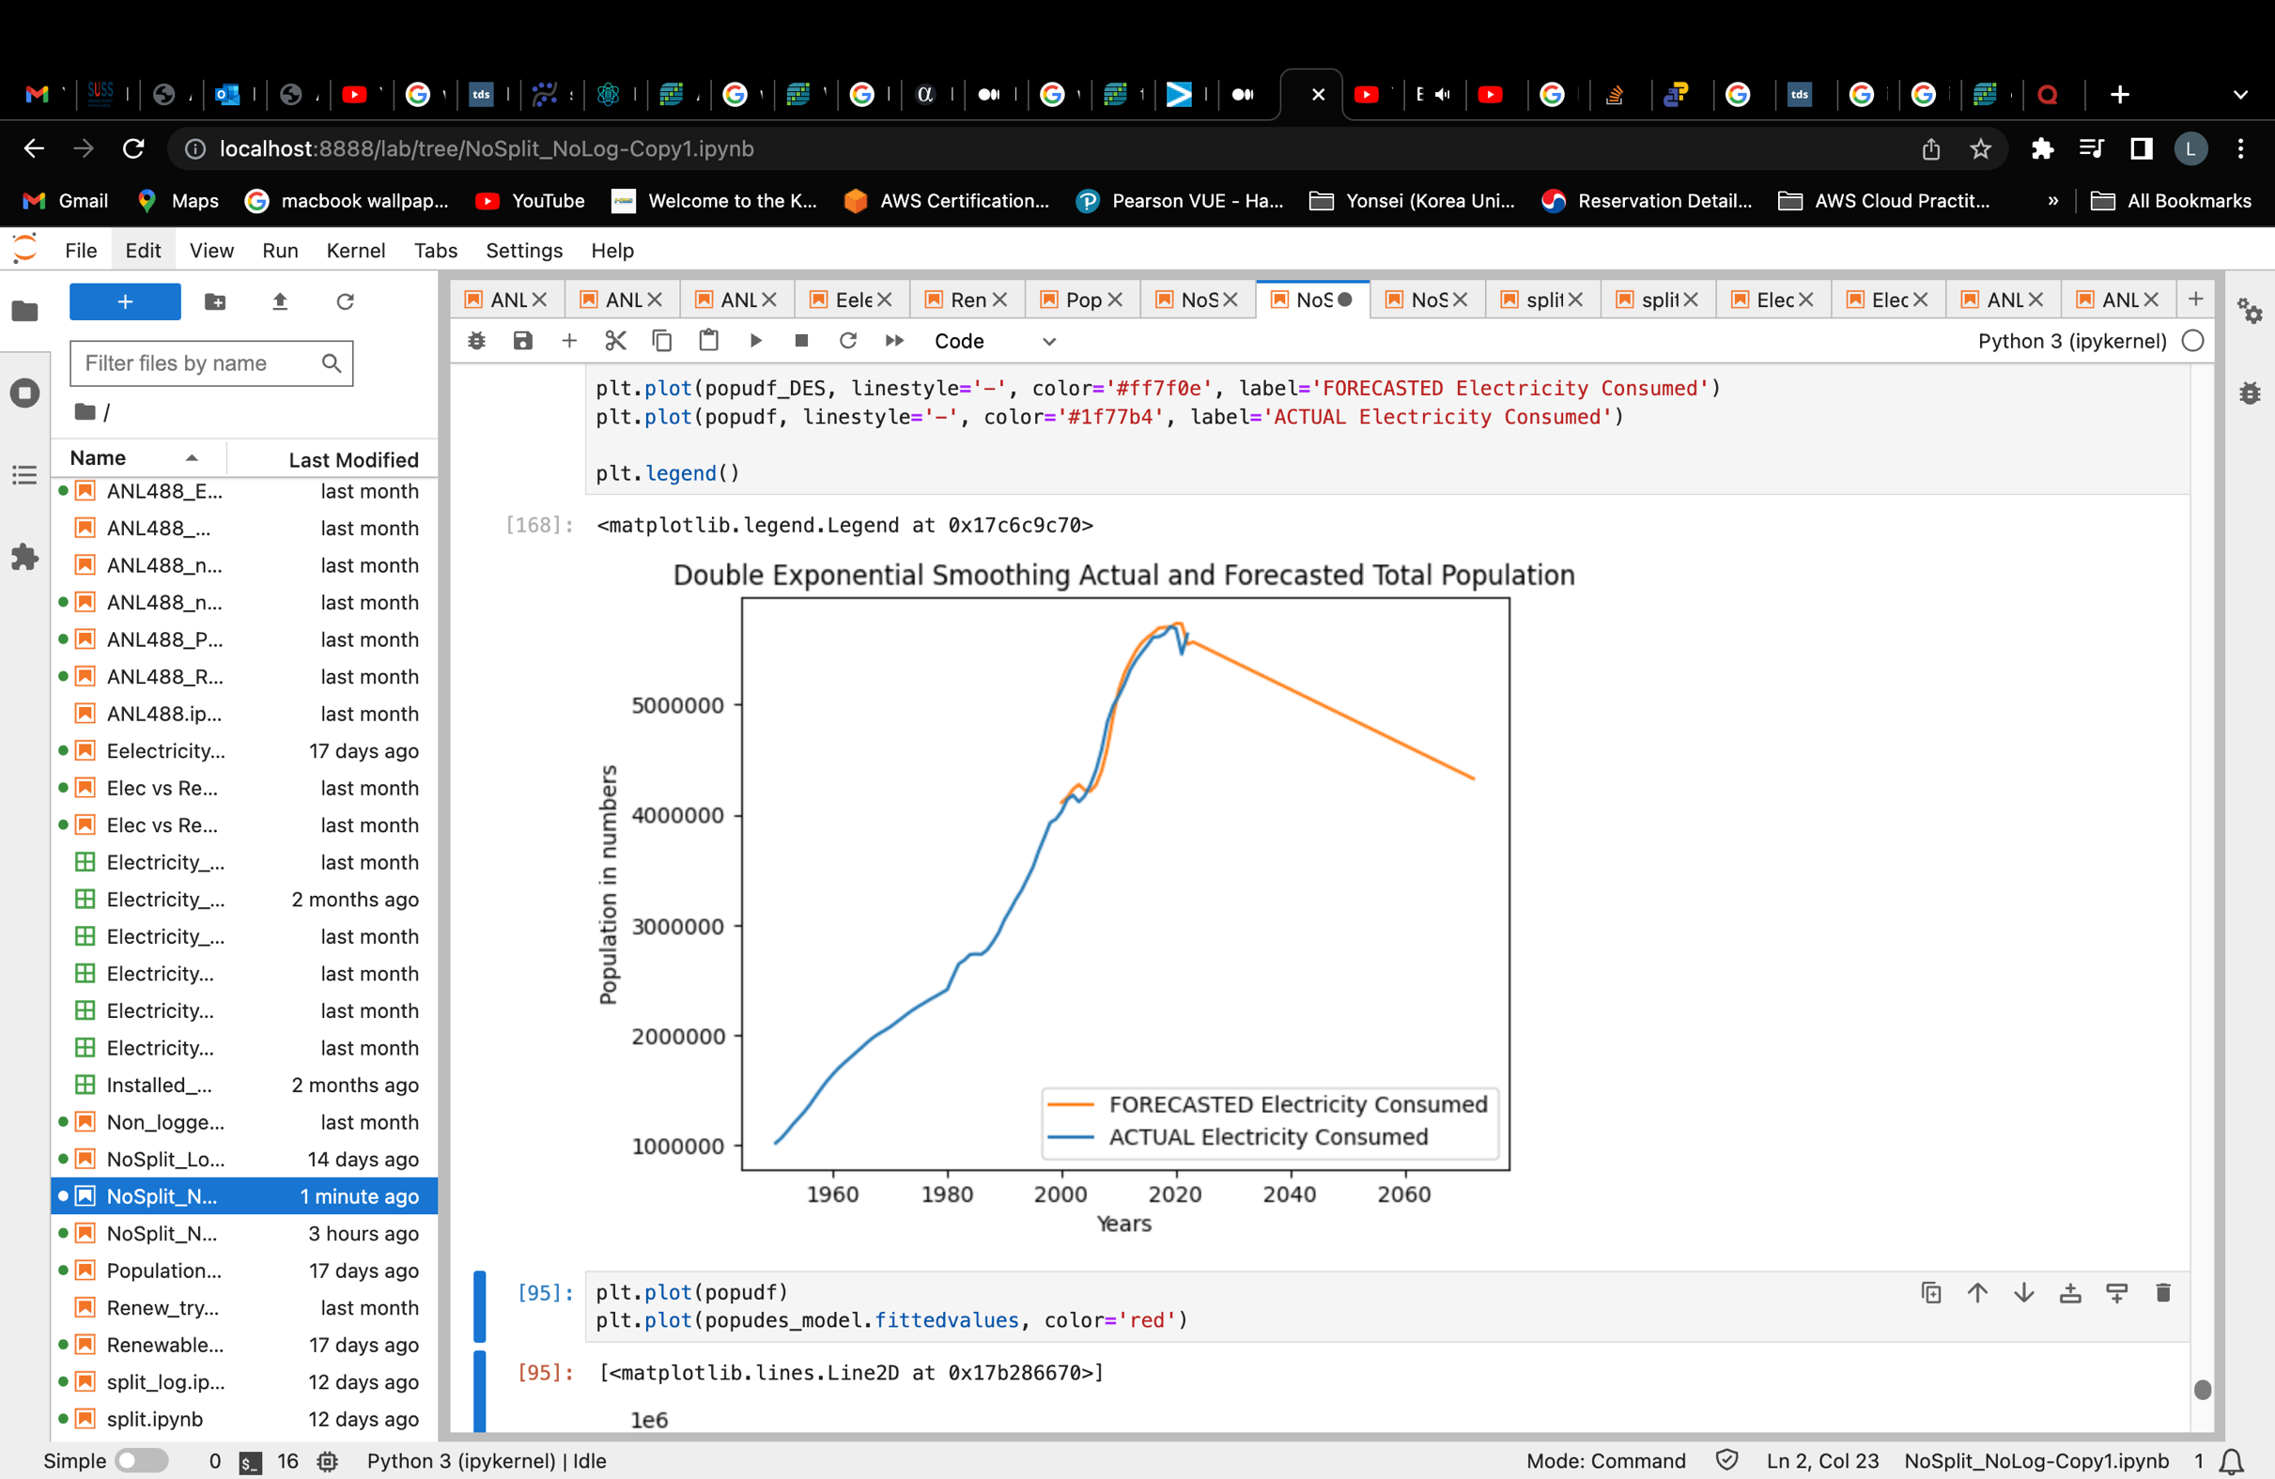

*Figure 6.3: Total Population dataset forecasting result using Holt’s Method*

Figure 6.3 shows the forecasted results of the total population dataset using the Holt’s Method (Double exponential Smoothing method). Here, we can see that the Holt’s model predicts Singapore’s population to decline in the future. Interestingly, this result widely defers from the results of the ARIMA(1,2,1) model modelled using the same dataset. Hence, the model comparison table below allows us to determine which model is a better fit for this dataset.

## ***Model Comparison Table***

|  |  |  |
| --- | --- | --- |
| Models | MAPE | R Square |
| ARIMA(1,2,1) | 0.036 | 0.987 |
| Holt’s Method (DES) | 0.013 | 0.998 |

*Table 17: Total Population dataset Model comparison table*

From table 17 above, we can deduce that the Holt’s method model will be a better fit for the population dataset as the MAPE is smaller compared the ARIMA model’s value and the R square value for the holt’s method is larger than the ARIMA model’s value. All of these indicates that the Holt’s method is a better for the dataset. Hence, the Holt’s Method will be adopted for the modelling of the population dataset.

Below summarizes the winner models for each dataset.

## **Winner Models**

|  |  |  |  |
| --- | --- | --- | --- |
| Datasets | Winner Model | MAPE | R Square |
| Singapore Electricity Consumption Dataset | Holt’s Method (DES) | 0.026 | 0.998 |
| Singapore’s Renewable Electricity Generated Dataset | ARIMA(1,1,1) | 0.16 | 0.932 |
| Singapore’s Total Population Dataset | Holt’s Method (DES) | 0.013 | 0.998 |

*Table 18: Winner model summarization table*

# **Model Results / Discussion**

The respective winner models are used to forecast the future electricity consumption levels, renewable electricity generated and total population in the next two decades to come till year 2043. The forecast results would be used to deduce:

1. The prediction of population would be analysed with the predicted electricity consumption values to realise any relationship between these two variables.
2. if the level of predicted renewable electricity generation is able to supplement the baseline of 60% of the predicted electricity consumption level in the same time period.

Now, let us look at the forecast results for each of the winner models using their respective datasets.

|  |  |
| --- | --- |
| Holt’s Method (DES) for Singapore Electricity Consumption Dataset | Holt’s Method (DES) for Singapore’s Total Population Dataset   |

*Figure 6.4: Holt’s method forecast results for Singapore’s electricity consumption and total population dataset*

From figure 6.4, we can see that the nation’s electricity consumption is predicted to increase steadily in the future. On the other hand, the nation’s population is set to be decreasing in the future. Hence, putting these 2 models and their forecasted values together, we can deduce that although the nation’s population is set to likely decrease in the future, the electricity consumed will still continue to increase nonetheless. This can likely be attributed to the fact that the world is now increasingly tech savvy and the future and current generation will no doubt incorporate more technology into our daily lives which in turn increases electricity consumption as well.

Next, to predicted if renewable electricity generation is able to supplement the baseline of 60% of the predicted electricity consumption level in any same period in the future, we will be looking at the forecast results of the respective models from the Singapore Electricity Consumption and Renewable Electricity Generated Dataset below.

|  |
| --- |
| Forecasted electricity consumption against renewable electricity generated figure.   |

*Figure 6.5: Forecasted electricity consumption & renewable electricity generated model*

Figure 6.5 shows the forecasted electricity consumption results generated from holt’s method (DES) plotted against the forecasted renewable electricity generated results from the ARIMA(,,) model. We can see that electricity consumption has a steeper increase forecasted compared to the renewable electricity generated forecast where it has a more gentle upward slope. However, it is clear that there will never be a point where these 2 forecasted results are able to intercept with each other at any one point in the future. Hence, we can conclude that the forecasted renewable electricity generated will not be able to supplement at least 60% of the forecasted electricity consumption in the next 2 decades to come.

# **Recommendations / Conclusion**

In conclusion, our study looks into 3 important aspects needed to deduce whether Singapore’s renewable electricity supply is able to sustain the nation’s electricity consumption levels for the next two decades to come. These 3 important aspects are namely Singapore’s renewable electricity generation level, electricity consumption level and total population.

Forecasting these 3 aspects using Holt’s method and the ARIMA model, our study was able to conclude a few points:

1. Population in the future will likely decrease.
2. Electricity Consumption will likely increase in the future.
3. Renewable electricity generation will likely increase in the future.
4. Electricity consumption levels will continue to increase despite decreasing population
5. Renewable electricity generation level in the future will not be able to supplement at least 60% of electricity consumption in the future

Hence, the final verdict deduced from the above forecast results would be that **Singapore is unable to dependent on renewable electricity** at least for the next 2 decades to come.

However, with the nation’s electricity security potentially threatened by the rapid depletion of non-renewable resources used to produce electricity today, it is important to continuously ensure that Singapore is able to hop onto the wave of becoming a renewable energy dominant country as soon as possible.

Hence, to ensure that Singapore is able to do so, the nation should continue to gradually increase the number of solar panel adoptions nation-wide. As solar power is the only most promising option Singapore can leverage on to generate renewable energy domestically, utilising the available and stipulated land would be crucial in producing optimal solar electricity. As of 2020, the total net usable area for facade photovoltaic (PV) systems, rooftop PV, mobile/land PV and floating PV are said to be 9.8 sq/km, 13.2 sq/km, 5.0 sq/km and 4.6 sq/km respectively. (Gorman, M & Bandera, M, 2022) These adds up to a net total of 32.6 sq/km available space in the nation to place solar panels on. In addition, as of 2022 Q1, there are a total of 5,455 solar panels already installed island wide. (Energy Market Authority, 2023, *Installed Capacity of Grid-Connected Solar Photovoltaic (PV) systems by User Type*) Hence, referring to diagram 1.0 in appendix, we can see that the maximum kWh of electricity Singapore can generate per year would be 2,162,968,092,700.00 kWh/year if the net usable area for solar panels is utilized. This will be able to power 479,508,755 HDB households in the nation which is a promising and substantial number.

Next, Singapore should continue to invest in research and development projects to leverage on the technology today to find more innovative ways to have more access points to renewable energy. These projects can include finding potential ways to tap on alternative renewable energy sources that were previously deemed un-applicable.

Also, as Singapore already have plans to import up to 4 gigawatts (GW) of renewable energy from neighboring countries by 2035, the nation should continue to import renewable energies sustainably and increase Singapore’s energy security for our future. (Tan, 2021)

Lastly, as much as increasing the supply of renewable energy for local use is important, an efficient way to store renewable energies generated or imported are equally as important to ensure enough renewable energy is safeguarded for the nation’s future consumption in the long run.

Thus, as Singapore continues to be a technologically advanced country, it is even more important for the nation to be technologically sustainable to safeguard the environment and the nation’s electricity security for future generations to come.

# **Project Limitations**

Future projects should include the adoption of other modelling techniques outside of time series analysis. Future projects should also address the nation’s carbon emission levels to determine whether carbon emission will decrease in the future. Lower carbon emission here refers to possibly a greater reliance on renewable energy. The nation’s level of investment and funding on renewable energy projects should also be studied in future projects.

**Word Count: 8439**

# **References**

Allwright, S. (2022, December 6). *What is a good MAPE score? (simply explained)*. Stephen Allwright. https://stephenallwright.com/good-mape-score/

Asadi, M., Larki, I., Mohammad, M. F., Ahmadi, R., & Farajollahi, M. (2023). Long-Term Scenario Analysis of Electricity Supply and Demand in Iran: Time Series Analysis, Renewable Electricity Development, Energy Efficiency and Conservation. Sustainability, 15(5), 4618. https://doi.org/10.3390/su15054618

Brownlee, J. (2020a, April 12). *A gentle introduction to exponential smoothing for time series forecasting in Python*. MachineLearningMastery.com. https://machinelearningmastery.com/exponential-smoothing-for-time-series-forecasting-in-python/

Brownlee, J. (2020b, August 14). *How to difference a time series dataset with python*. MachineLearningMastery.com. https://machinelearningmastery.com/difference-time-series-dataset-python/#:~:text=Differencing%20can%20help%20stabilize%20the,or%20reducing)%20trend%20and%20seasonality.&text=Differencing%20is%20performed%20by%20subtracting%20the%20previous%20observation%20from%20the%20current%20observation.&text=In%20this%20way%2C%20a%20series%20of%20differences%20can%20be%20calculated.

Dearing, P. (2023, August 31). *Solar panel size and weight explained: How big are solar panels?* . Solar Energy World. https://www.solarenergyworld.com/solar-panel-size-and-weight-explained-how-big-are-solar-panels/#:~:text=The%20standard%20size%20for%20a,in%20actual%20size%20between%20manufacturers.

Department Of Statistics Singapore. (2023). *Singapore Statistical System - Who We Are*. DOS SingStat. https://www.singstat.gov.sg/who-we-are/singapore-statistical-system#:~:text=Singapore%20has%20adopted%20a%20decentralised,government%20ministries%20and%20statutory%20boards.

Energy Market Authority - EMA. (2023). *Industry Liscence*. Energy Market Authority - EMA. https://www.ema.gov.sg/regulations-licences/licences/industry-licences

Energy Market Authority – EMA. (2023) *Installed Capacity of Grid-Connected Solar Photovoltaic (PV) systems by User Type*. Energy Market Authority - EMA. https://www.ema.gov.sg/resources/statistics/installed-capacity-of-grid-connected-solar-photovoltaic-systems

Gorman, M., & Bandera, M. (2022, July 4). *Commentary: Why is sunny singapore not covered with rooftop solar panels?*. CNA. https://www.channelnewsasia.com/commentary/singapore-renewable-energy-rooftop-buildings-solar-electricity-costs-2782796

Goh, T. (2020, October 14). *Parliament: Increased household electricity and gas consumption from April to July due to Covid-19 measures*. Retrieved from straitstimes.com: https://www.straitstimes.com/singapore/politics/parliament-increased-household-electricity-and-gas-consumption-from-april-to-july

G, V. K. (2023, June 6). *Statistical tests to check stationarity in time series*. Analytics Vidhya. https://www.analyticsvidhya.com/blog/2021/06/statistical-tests-to-check-stationarity-in-time-series-part-1/#:~:text=A%20Stationary%20series%20is%20one,a%20Trend%20or%20Seasonal%20components.

IEA. (2023). *Electricity - Energy System*. IEA - International Energy Agency. https://www.iea.org/energy-system/electricity

IEA. (2023). *International Energy Agency - About*. About IEA - International Energy Agency. https://www.iea.org/about

*Installed Capacity of Grid-Connected Solar Photovoltaic (PV) systems by User Type*. Energy Market Authority - EMA. (2023). https://www.ema.gov.sg/resources/statistics/installed-capacity-of-grid-connected-solar-photovoltaic-systems

Jaisumroum, N., & Teeravaraprug, J. (2017). Forecasting uncertainty of Thailand’s electricity consumption compare with using artificial neural network and multiple linear regression methods. 2017 12th IEEE Conference on Industrial Electronics and Applications (ICIEA), 308–313. https://doi.org/10.1109/ICIEA.2017.8282862

Kumar, S. (2022, January 18). *ML algorithm that natively supports missing values*. Medium. https://towardsdatascience.com/ml-algorithm-that-natively-supports-missing-values-40b42559c1ec#:~:text=Most%20of%20the%20machine%20learning,based%20Gradient%2Dboosting%20Classifier%20%2F%20Regressor

Kuo, G. (2019, August 23). When fossil fuels run out, what then?. MAHB. https://mahb.stanford.edu/library-item/fossil-fuels-run/#:~:text=Yes%2C%20we%20are%20rapidly%20depleting,renewables%20and%20remainder%20by%20nuclear.

Lianne, & Justin. (2022, August 25). *How to build Arima models in Python for time series prediction*. Just into Data. https://www.justintodata.com/arima-models-in-python-time-series-prediction/

linkedin. (2023). *What are the advantages and disadvantages of Sarima models over Arima models?*. SARIMA vs ARIMA Models: A Comparison Guide. https://www.linkedin.com/advice/0/what-advantages-disadvantages-sarima-models#:~:text=There%20is%20no%20definitive%20answer,any%20seasonal%20patterns%20or%20trends.

Manni, U. H., & Mansur, D. K. H. M. (2022). AN INVESTIGATION OF INDONESIA'S TRANSITION TOWARDS RENEWABLE ENERGY USING TIME SERIES ANALYSIS. Journal of Energy and Development, 47(2), 297-325,335-336. https://www.proquest.com/scholarly-journals/investigation-indonesias-transition-towards/docview/2768535344/se-2

*Mean squared error: Definition and example*. Statistics How To. (2021, June 26). https://www.statisticshowto.com/probability-and-statistics/statistics-definitions/mean-squared-error/

Mills, T. C. (2019, January 25). *Arma models for Stationary time series*. Applied Time Series Analysis. https://www.sciencedirect.com/science/article/abs/pii/B978012813117600003X

Otext. (2023). *Forecasting: Principles and practice (2nd ed)*. 7.1 Simple exponential smoothing. https://otexts.com/fpp2/ses.html

Pannakkong, W., Harncharnchai, T., & Buddhakulsomsiri, J. (2022). Forecasting daily electricity consumption in Thailand using regression, artificial neural network, support vector machine, and hybrid models. Energies, 15(9), 3105.

PennState - Eberly College of Science. (2023). *5.1 decomposition models: Stat 510*. PennState: Statistics Online Courses. https://online.stat.psu.edu/stat510/lesson/5/5.1#:~:text=How%20to%20Choose%20Between%20Additive,seasonal%20variation%20increases%20over%20time.

Powering Lives (2023, August 18) Singapore’s Energy Journey. https://www.poweringlives.gov.sg/about/singapore-energy-story/

Rasheed, R. (2020, July 12). *Why does stationarity matter in time series analysis?*. Medium. https://towardsdatascience.com/why-does-stationarity-matter-in-time-series-analysis-e2fb7be74454

Rekhade, R., & Sakhare, D. K. (2021). Forecasting sector-wise electricity consumption for India using various regression models. Current Science, 121(3), 365.

*Singapore: Daily sunshine hours 2022*. Statista. (2023, May 10). https://www.statista.com/statistics/879697/singapore-daily-sunshine-hours/

Shinn, L. (2022, June 1). Renewable energy: The clean facts. Renewable Energy Definition - Sources, Clean Alternatives. https://www.nrdc.org/stories/renewable-energy-clean-facts#sec-whatis

Smigel, L. (2023, October 14). *How to interpret arima results*. Analyzing Alpha. https://analyzingalpha.com/interpret-arima-results

Sozen, A. (2009). Future projection of the energy dependency of Turkey using artificial neural network. Energy Policy, 37(11), 4827–4833. https://doi.org/10.1016/j.enpol.2009.06.040

Tan, A. (2021, October 25). *Singapore plans to import 30% of energy from low-carbon sources by 2035*. The Straits Times. https://www.straitstimes.com/singapore/environment/singapore-plans-to-import-30-of-energy-from-low-carbon-sources-by-2035

Taylor, S. (2023, August 11). *R-squared*. Corporate Finance Institute. https://corporatefinanceinstitute.com/resources/data-science/r-squared/

The World Bank. (2023). *The World Bank - Data Catalog*. World Development Indicators. https://datacatalog.worldbank.org/search/dataset/0037712

*Univariate time series analysis and forecasting with Arima/Sarima*. Section. (2022, May 11). https://www.section.io/engineering-education/univariate-time-series-analysis-with-arima-in-python/

Yoo, S.-H. (2006). The causal relationship between electricity consumption and economic growth in the ASEAN countries. Energy Policy, 34(18), 3573–3582. https://doi.org/10.1016/j.enpol.2005.07.011

# **Appendix**

DATA PROCESSING SECTION

|  |  |
| --- | --- |
| **Figure Number** | **Figure** |
| ***Figure 1.1****:* *Null values present in electricity consumption dataset* |  |
| ***Figure 1.2:*** *Removing null values from “Electricity_Consumption_1971_2014.csv” file* |  |
| ***Figure 1.3:*** *Checking for null values in electricity consumption dataset after removal* |  |
| ***Figure 2.1:*** *Null values present in renewable electricity dataset* |  |
| ***Figure 2.2:***  *Removing null values from “Electricity_From_Renewables_new.csv” file* |  |
| ***Figure 2.3:***  *Checking for null values in renewable electricity dataset after removal* |  |
| ***Figure 2.4:*** *Checking renewable electricity dataset for stationarity before differencing* | *Checking for stationarity* ***before*** *differencing*   |
| ***Figure 2.5:*** *Renewable electricity generated dataset visualization graph* |  |
| ***Figure 2.6:*** *Checking renewable electricity dataset for stationarity after 1st order differencing* | *Checking for stationarity* ***after*** *differencing*   |
| ***Figure 2.7:*** *Checking renewable electricity dataset for stationarity after 2nd order differencing* | *Checking for stationarity* ***after*** *differencing*   |
| ***Figure 3.1:*** *Null values present in Total Population dataset* |  |
| ***Figure 3.2:*** *Setting Total Population dataset’s time element as index* |  |
| ***Figure 3.3:*** *Checking Total Population dataset for stationarity before differencing* | *Checking for stationarity* ***before*** *differencing*   |
| ***Figure 3.4:*** *Total Population dataset Visualisation Graphs* |  |
| ***Figure 3.5:*** *Checking renewable electricity dataset for stationarity after 2nd order differencing* | *Checking for stationarity* ***after*** *differencing*   |

MODELLING AND EVALUATION / DISCUSSION SECTION

|  |  |
| --- | --- |
| ***Figure 4.1:***  *Results after 1st order of differencing* | **After 1st order of differencing**   |
| ***Figure 4.2:***  *Results after 2nd order of differencing* | **After 2nd order of differencing**   |
| ***Figure 4.3:***  *Results after 3rd order of differencing* | **After 3rd order of differencing**   |
| ***Figure 4.5:***  *ARIMA(1,3,2) Model Summary for Electricity Dataset* |  |
| ***Figure 4.6:***  *ARIMA(2,3,2) Model Summary for Electricity Dataset* |  |
| ***Figure 4.9:***  *Results after 1st order of differencing* | **After 1st order of differencing**   |
| ***Figure 5.0:***  *Results after 2nd order of differencing* | **After 2nd order of differencing**   |
| ***Figure 5.2:*** *ARIMA(1,2,1) Model Summary for Renewable Dataset* |  |
| ***Figure 5.5:***  *Results after 1st order of differencing* | **After 1st order of differencing**   |
| ***Figure 5.6:***  *Results after 2nd order of differencing* | **After 2nd order of differencing**   |
| **Figure 5.8:** ARIMA(1,2,1) Model Summary |  |
| **Figure 5.9:** ARIMA(1,2,2) Model Summary |  |
| **Figure 6.0:** ARIMA(2,2,1) Model Summary |  |
| **Figure 6.1**: ARIMA(2,2,2) Model Summary |  |

RECCOMENDATIONS / CONCLUSION

|  |  |
| --- | --- |
| ***Diagram 1.0:***  *Total electricity producible from Solar panels installed on total net available area* |  |

The Information in Diagram 1.0 above were self-consolidated and sourced from the following references:

Energy Market Authority – EMA. (2023) *Installed Capacity of Grid-Connected Solar Photovoltaic (PV) systems by User Type*. Energy Market Authority - EMA. https://www.ema.gov.sg/resources/statistics/installed-capacity-of-grid-connected-solar-photovoltaic-systems

Dearing, P. (2023, August 31). *Solar panel size and weight explained: How big are solar panels?* . Solar Energy World. https://www.solarenergyworld.com/solar-panel-size-and-weight-explained-how-big-are-solar-panels/#:~:text=The%20standard%20size%20for%20a,in%20actual%20size%20between%20manufacturers.

Gorman, M., & Bandera, M. (2022, July 4). *Commentary: Why is sunny singapore not covered with rooftop solar panels?*. CNA. https://www.channelnewsasia.com/commentary/singapore-renewable-energy-rooftop-buildings-solar-electricity-costs-2782796

*Singapore: Daily sunshine hours 2022*. Statista. (2023, May 10). https://www.statista.com/statistics/879697/singapore-daily-sunshine-hours/